**The world in our hands**

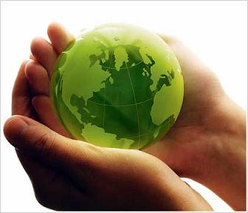

**The newspaper was created by the students of fifth class of 1st primary school of Thrakomakedones for Erasmus project 2014**

Dear children

I would like to thank you all for the great work you have done!!!!I hope this newspaper was as interesting and stimulating as it could be for you…you have been a great inspiration …this is why I dedicate it to all of you who have worked so hard to produce such a great work!! Enjoy!!!

I would like to thank Mrs Vasiliadou Olga the headmistress of our school for her valuable support and Mrs Alexopoulou Athanasia the teacher of computers for her guidance with the use of this important tool to create the newspaper.

Daskalopoulou Aggeliki English teacher

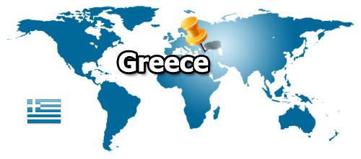

**Presentation of Greece**

**By Gouskou S.Konstantinou C.E1**

**Greece is a truly unique location. Despite its small size, the country enjoys**

**a particularly pristine and diverse natural environment that offers everything from**

**scenic island getaways to cozy mountain retreats. The country’s stunning topography**

**provides the backdrop for an unequalled array of recreational opportunities.**

**This, combined with a spirited lifestyle that blends the Mediterranean’s ancient**

**and modern culture, makes Greece a simply extraordinary place to be and a**

**wonderful place to** [**call**](http://www.investingreece.gov.gr/default.asp?pid=53&la=1) **home.**

**Greece offers the visitor and resident unlimited opportunities to explore the very**

**roots of Western civilization. Throughout the country, there are hundreds of museums,**

**archaeological sites, and monuments that detail the rise of art, architecture,**

**crafts, design, ideas and thought.**

**Presentation of Greece**

**By M. Kamba and L. Tsatsi**

**Greece officially the Hellenic Republic is known since ancient times as Hellas , is a country in Southern Europe. According to the 2011 census, Greece's population is around 11 million.**

**Athens is the nation's capital and largest city.**

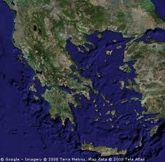Greece is strategically located at the crossroads of Europe, Western Asia, and Africa, and shares land borders with Albania to the northwest, the Republic of Macedonia and Bulgaria to the north and Turkey to the northeast. The country consists of nine geographic regions: Macedonia, Central Greece, the Peloponnese, Thessaly, Epirus, the Aegean Islands (including the Dodecanese and Cyclades), Thrace, Crete, and the Ionian Islands. The Aegean Sea lies to the east of the mainland, the Ionian Sea to the west, and the Mediterranean Sea to the south. Greece has the longest coastline on the Mediterranean Basin and the 11th longest coastline in the world at 13,676 km (8,498 mi) in length, featuring a vast number of islands (approximately 1,400, of which 227 are inhabited). Eighty percent of Greece consists of mountains, of which Mount Olympus is the highest, at 2,917 m (9,570 ft).

**Modern Greece traces its roots to the civilization of Ancient Greece, which is considered the cradle of all Western civilization. As such, it is the birthplace of democracy, Western philosophy, the Olympic Games, Western literature and historiography, political science, major scientific and mathematical principles, and Western drama, including both tragedy and comedy. The cultural and technological achievements of Greece greatly influenced the world, with many aspects of Greek civilization being imparted to the East through Alexander the Great's campaigns, and to the West through the Roman Empire. This rich legacy is partly reflected in the 17 UNESCO World Heritage Sites located in Greece, ranking it 7th in Europe and 13th in the world. The modern Greek state, which comprises much of the historical core of Greek civilization, was established in 1830 following the Greek War of Independence from the Ottoman Empire.**

Greece is a founding member of the United Nations, has been a member of what is now the European Union since 1981 (and the eurozone since 2001), and has been a member of NATO since 1952.

**Greek History**

**By Dimitris Doulogeris and Kostas Vallios**

**The earliest evidence of human presence in the Balkans, dated to 270,000 BC, is to be found in the Petralona cave, in the northern Greek province of Macedonia.  Neolithic settlements in Greece, dating from the 7th millennium BC, are the oldest in Europe by several centuries, as Greece lies on the route via which farming spread from the Near East to Europe.**

**The archaic period**

Greek territories and colonies during the **Archaic period (750-550** BC).

[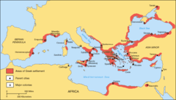](http://en.wikipedia.org/wiki/File:Greek_Colonization.png)

**Greece is home to the first advanced civilizations in Europe** **and is considered the birthplace of** **Western civilization**, beginning with the **Cycladic civilization** on the islands of the Aegean Sea at around 3200 BC, **the Minoan civilization in Crete** (2700–1500 BC), and then the **Mycenaean civilization** on **the mainland (**1900–1100 BC).  These civilizations **possessed writing**, the Minoans **writing in an undeciphered** **script known as Linear A,** **and the Myceneans in Linear B,** an early form of Greek.  The Myceneans gradually absorbed the Minoans, but collapsed violently around 1200 BC, during a time of regional upheaval known as the Bronze Age collapse.  This ushered in a period known as the Greek Dark Ages,

**[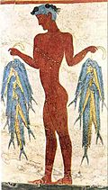](http://en.wikipedia.org/wiki/File:Akrotiri-fisherman.jpg)Minoan fresco at Akrotiri of Santorini.**

**Cycladic civilization**

.

**The end of the Dark Ages is traditionally dated to 776 BC, the year of the first Olympic Games.**  **The Iliad and the Odyssey, the foundational texts of Western literature**, are believed to have been composed by **Homer** in the 8th or 7th centuries BC. With the end of the Dark Ages, there emerged various kingdoms and city-states across the Greek peninsula, **which spread to the shores of the** **Black Sea, Southern Italy** (**Latin: Magna Graecia, or Greater Greece)** and Asia Minor.  These states and their colonies **reached great levels of prosperity t**hat resulted in an unprecedented **cultural boom, that of classical Greece,** expressed in **architecture, drama, science, mathematics and** **philosophy. In** 508 BC, **Cleisthenes instituted the world's first democratic system of government in Athens.**

By 500 BC, the **Persian Empire** controlled territories ranging from their home Iran all the way to what is now northern Greece and Turkey, and posed a threat to the Greek states.  Attempts by the Greek city-states of Asia Minor to overthrow Persian rule failed, and **Persia invaded the states of** **mainland Greece** in 492 BC, but was forced to withdraw after a defeat **at the Battle of Marathon** in 490 BC.  A second invasion followed in 480 BC.  **Despite a heroic resistance at Thermopylae by Spartans and other Greeks, Persian forces sacked Athens.**

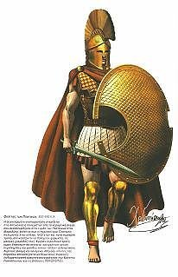Sparta in the Attic dialect ) was a city -state in ancient Greece that was built on the banks of the River Eurotas in Laconia in the south eastern part of the Peloponnese . Has fallen well known in world history for military strength, discipline , heroism and the large number of slaves . It is known in Greek mythology , particularly the myth of Helen **. The military power of Sparta was** due **to the system of education imposed by the laws of Lycurgus** , which was unique in ancient Greece . The historical period of Sparta begins with the descent of the Dorians around 1100 BC , ( although archeology argues that the Dorian invasion was later ) and ends during the Roman period , although there is clear evidence for the influence of Mycenaean civilization in the region long before the arrival of the Dorians , which considered the history of Ancient Sparta. **During Classical Antiquity, Sparta was one of the two most powerful city-states in ancient Greece ,** including Athens. Sparta began to emerge as a politico - military power in Greece at the beginning of the Archaic Period after the end of the dark ages of the Geometric period and reached the absolute edge after winning the Peloponnesian War on Athens and its allies , and when succeeded in imposing its hegemony and influence in much of the ancient world . The rule did not last long and after defeats by Thebes in 371 BC and Leuctra in 362 BC Mantinea lost its old strength, simultaneously with the rise of the kingdom of Macedonia began to play a minor role in Greek affairs . Some glimpses of the 3rd century BC did not prevent the decline following the fate of the rest Greek world was conquered by the Romans . But during the Roman period continued to be a center of attraction because of its rich history

**By Thomopoulos k**

**Following successive Greek victories** in 480 and 479 BC at **Salamis, Plataea and Mycale**, the Persians were forced to withdraw for a second time.  **The military conflicts**, known as the **Greco-Persian Wars,** were led mostly by Athens and Sparta.  The fact that Greece was not a unified country meant that conflict between the Greek states was common.

**The most devastating intra-Greek war** in classical antiquity was the **Peloponnesian War (**431–404 BC), which marked the **demise of the Athenian Empire as the leading power in ancient Greece.**  Both Athens and Sparta were later overshadowed by Thebes and eventually **Macedon,** with the latter uniting the Greek world in the League of Corinth (also known as the Hellenic League or Greek League) under the guidance of Phillip II**, who was elected leader of the first unified Greek** **state in history.**

[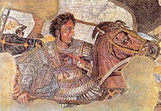](http://en.wikipedia.org/wiki/File:BattleofIssus333BC-mosaic-detail1.jpg)

Following the assassination of Phillip II, **his son Alexander III** ("The Great") assumed the leadership of the League of Corinth and launched an invasion of the Persian Empire with the combined forces of all Greek states in 334 BC.  Following Greek victories in the battles of **Granicus, Issus and Gaugamela**, the Greeks marched on Susa and Persepolis, the ceremonial capital of **Persia, in** 330 BC.  **The Empire created by Alexander the Great stretched from Greece in the west and Pakistan in the east and Egypt in the south.**

Before his sudden death in 323 BC, Alexander was also planning an invasion of Arabia.  **His death marked the collapse of the vast empire, which was split into several kingdoms, the most famous of which were the Seleucid Empire and Ptolemaic Egypt.  Other states founded by Greeks include the Greco-Bactrian Kingdom and the Greco-Indian Kingdom in India.** Although the political unity of Alexander's empire could not be maintained, **it brought about the dominance** of **Hellenistic civilization** and the **Greek language i**n the territories **conquered by Alexander for** at least two centuries,

### Hellenistic and Roman periods (323 BC–4th century AD)

**The Antikythera mechanism (c. 100 BC) is believed to be the earliest mechanical analog computer (National Archaeological Museum, Athens).**

After a period of confusion following Alexander's death, the Antigonid dynasty, descended from one of Alexander's generals, established its control over Macedon by 276 BC, as well as hegemony over most of the Greek city-states.  From about 200 BC the Roman Republic became increasingly involved in Greek affairs and engaged in a series of wars with Macedon.  Macedon's defeat at the Battle of Pydna in 168 BC signaled the end of **Antigonid p**ower in Greece.  **In 146 BC Macedonia was annexed as a province by Rome, and the rest of Greece became a Roman protectorate**.

The process was completed in 27 BC when the Roman Emperor Augustus annexed the rest of Greece and constituted it as the senatorial province of Achaea.  Despite their military superiority, **the Romans admired and became heavily influenced by the achievements of Greek culture,** hence Horace's famous statement: Graecia capta ferum victorem cepit ("Greece, although captured, took its wild conqueror captive").]  **Greek science, technology and mathematics are generally considered to have reached their peak during the Hellenistic period.**

**Greek-speaking communities of the Hellenized East were instrumental in the spread of early Christianity in the 2nd and 3rd centuries, and Christianity's early leaders and writers were generally Greek-speaking, though none were from Greece.**

### Medieval period (4th century–1453)

**The Byzantine Empire at its greatest extent under Justinian I, in 555 AD.**

[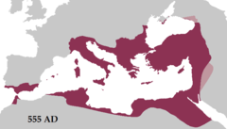](http://en.wikipedia.org/wiki/File:Justinian555AD.png)The Roman Empire in the east, following the fall of the Empire in the west in the 5th century, is conventionally known as the Byzantine Empire (but was simply called "Roman Empire" in its own time) and lasted until 1453.  **With its capital in Constantinople, its language and literary culture was Greek and its religion was predominantly Eastern Orthodox Christian.**

From the 4th century, the Empire's Balkan territories, including Greece, suffered from the dislocation of the Barbarian Invasions.  The raids and devastation of the Goths and Huns in the 4th and 5th centuries and the Slavic invasion of Greece in the 7th century resulted in a dramatic collapse in imperial authority in the Greek peninsula.  Following the Slavic invasion, the imperial government retained control of only the islands and coastal areas, particularly cities such as Athens, Corinth and Thessalonica, while some mountainous areas in the interior held out on their own and continued to recognize imperial authority.  Outside of these areas, a limited amount of Slavic settlement is generally thought to have occurred, although on a much smaller scale than previously thought.

[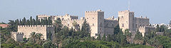](http://en.wikipedia.org/wiki/File:Maltan_knights_castle_in_rh.jpg)

**Palace of the Grand Master of the Knights of Rhodes, remain of the Knights period of the island.**

[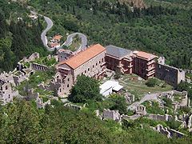](http://en.wikipedia.org/wiki/File:Mystras_palace.JPG)

**Mystras Palace, remain of the Despotate of the Morea.**

The Byzantine recovery of lost provinces began toward the end of the 8th century and most of the Greek peninsula came under imperial control again, in stages, during the 9th century.  This process was facilitated by a large influx of Greeks from Sicily and Asia Minor to the Greek peninsula, while at the same time many Slavs were captured and re-settled in Asia Minor and those that remained were assimilate]  During the 11th and 12th centuries the return of stability resulted in the Greek peninsula benefiting from strong economic growth – much stronger than that of the Anatolian territories of the Empire.

Following the Fourth Crusade and the fall of Constantinople to the "Latins" in 1204 most of Greece quickly came under Frankish rule (**initiating the period known as the Frankokratia) or** **Venetian rule in the case of some of the islands.** The re-establishment of the Byzantine Empire in Constantinople in 1261 was accompanied by the recovery of much of the Greek peninsula, although the Frankish Principality of Achaea in the Peloponnese remained an important regional power into the 14th century, **while the islands remained largely under Genoese and Venetian control.**

In the 14th century much of the Greek peninsula was lost by the Empire as first the Serbs and then the Ottomans seized imperial territory.  By the beginning of the 15th century, the Ottoman advance meant that Byzantine territory in Greece was limited mainly to the Despotate of the Morea in the Peloponnese. After the fall of Constantinople to the Ottomans in 1453, the Morea was the last remnant of the Byzantine Empire to hold out against the Ottomans.  However, this, too, fell to the Ottomans in 1460, completing the Ottoman conquest of mainland Greece.  With the Turkish conquest, many Byzantine **Greek scholars, who up until then were largely responsible for preserving Classical Greek knowledge, fled to the West, taking with them a large body of literature and thereby significantly contributing to the Renaissance.**

### Ottoman period (15th century–1821)

[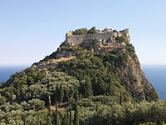](http://en.wikipedia.org/wiki/File:Angelokastro_(Corfu).jpg)

The Byzantine castle of Angelokastro successfully repulsed the Ottomans during the first great siege of Corfu in 1537, the siege of 1571, and the second great siege of Corfu in 1716 causing them to abandon their plans to conquer Corfu.

[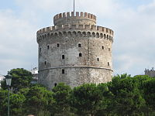](http://en.wikipedia.org/wiki/File:B%C3%ADl%C3%A1_v%C4%9B%C5%BE,_Thesalloniki.jpg)

**The White Tower of Thessaloniki, one of the best-known Ottoman structures remaining in Greece.**

**While most of mainland Greece and the Aegean islands was under Ottoman control** by the end of the 15th century, **Cyprus and Crete remained Venetian territory** and did not fall to the Ottomans until 1571 and 1670 respectively.  The only part of the Greek-speaking world that escaped long-term Ottoman rule was **the Ionian Islands, which remained Venetian** until their capture by the First French Republic in 1797, **then passed to the United Kingdom** in 1809 **until their unification with Greece in 1864.**

While Greeks in the Ionian Islands and Constantinople lived in prosperity, the latter achieving positions of power within the Ottoman administration, much of the population of mainland Greece **suffered the economic consequences of the Ottoman conquest**.  Heavy taxes were enforced, and in later years the Ottoman Empire enacted a policy of creation of hereditary estates, effectively turning the rural Greek populations into serfs.

The Greek Orthodox Church and the Ecumenical Patriarchate of Constantinople were considered by the Ottoman governments as the ruling authorities of the entire Orthodox Christian population of the Ottoman Empire, whether ethnically Greek or not.  Although the Ottoman state did not force non-Muslims to convert to Islam, Christians faced several types of discrimination intended to highlight their inferior status in the Ottoman Empire.  Discrimination against Christians, particularly when combined with harsh treatment by local Ottoman authorities, led to conversions to Islam, if only superficially.  In the nineteenth century, many "crypto-Christians" returned to their old religious allegiance.

The nature of Ottoman administration of Greece varied, though it was invariably arbitrary and often harsh**.]  Some cities had governors appointed by the Sultan, while others** (like Athens) were self-governed municipalities.  **Mountains regions in the interior and many islands remained effectively autonomous from the central Ottoman state for many centuries.**

When military conflicts broke out between the Ottoman Empire and other states, Greeks usually **took arms against the Empire,** with few exceptions.  Prior to the Greek revolution, there had been a number of wars which saw Greeks fight against the Ottomans, such as the Greek participation in the Battle of Lepanto in 1571, the Epirus peasants' revolts of 1600–1601, the Morean War of 1684–1699, and the Russian-instigated Orlov Revolt in 1770, which aimed at breaking up the Ottoman Empire in favor of Russian interests These uprisings were put down by the Ottomans with great bloodshed.

The 16th and 17th centuries are regarded as something **of a "dark age" in Greek history,** with the prospect of overthrowing Ottoman rule appearing remote with only the Ionian islands remaining free of Turkish domination.  Corfu withstood three major sieges in 1537, 1571 and 1716 all of which resulted in the repulsion of the Ottomans.  However in the 18th century, there arose through shipping a wealthy and dispersed Greek merchant class.  **These merchants came to dominate trade within the Ottoman Empire, establishing communities throughout the** **Mediterranean, the Balkans, and Western Europe.**  **Though the Ottoman conquest had cut Greece off from significant European intellectual movements such as the Reformation and the Enlightenment, these ideas together with the ideals of the French Revolution and romantic nationalism began to penetrate the Greek world via the mercantile diaspora.  In the late 18th century, Rigas Feraios, the first revolutionary to envision an independent Greek state, published a series of documents relating to Greek independence, including but not limited to a national anthem and the first detailed map of Greece, in Vienna, and was murdered by Ottoman agents in 1798.**

### Greek War of Independence (1821–1832)

[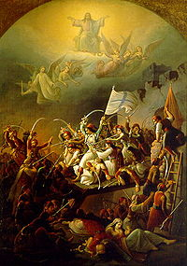](http://en.wikipedia.org/wiki/File:The_sortie_of_Messologhi_by_Theodore_Vryzakis.jpg)

**The sortie of Messolonghi, during the Greek War of Independence (1821–1830), by Theodoros Vryzakis**.

In 1814, a secret organization called the **Filiki Eteria** (Society of Friends) was founded with the **aim of liberating Greece.**  The Filiki Eteria planned to launch revolution in the Peloponnese, the Danubian Principalities and Constantinople.  The first of these revolts began **on 6 March 1821** in the Danubian Principalities under the leadership of **Alexandros Ypsilantis**, but it was soon put down by the Ottomans.  **The events in the north spurred the Greeks of the Peloponnese into action and on 17 March 1821 the Maniots declared war on the Ottomans.**

By the end of the month, **the Peloponnese** was in open revolt against the Ottomans and by October 1821 the Greeks under **Theodoros Kolokotronis** had captured Tripolitsa.  **The Peloponnesian revolt** was quickly followed **by revolts in Crete, Macedonia and Central Greece,** which would soon be suppressed.  Meanwhile, the makeshift Greek navy was achieving success against the Ottoman navy in the Aegean Sea and prevented Ottoman reinforcements from arriving by sea.  In 1822 and 1824 **the Turks and Egyptians** ravaged the islands, including **Chios and Psara,** committing wholesale massacres of the population. **This had the effect of galvanizing public opinion in western Europe in favor of the Greek rebels.**

Tensions soon developed among different Greek factions, leading to two consecutive **civil wars.**  Meanwhile, the Ottoman Sultan negotiated with **Mehmet Ali of Egypt**, who agreed to send his son **Ibrahim Pasha** to Greece with an army to suppress the revolt in return for territorial gain.  Ibrahim landed in the Peloponnese in February 1825 and had immediate success: by the end of 1825, most of the Peloponnese was under **Egyptian control,** and the **city of Missolonghi**—put under siege by the Turks since April 1825—fell in April 1826.  Although Ibrahim was defeated in Mani, he had succeeded in suppressing most of the revolt in the Peloponnese and Athens had been retaken.

After years of negotiation, three Great Powers, Russia, the United Kingdom and France, decided to intervene in the conflict and each nation sent a navy to Greece.  Following news that combined Ottoman–Egyptian fleets were going to attack the Greek island of Hydra**, the allied fleet** intercepted the Ottoman–Egyptian fleet **at Navarino.**  After a week-long standoff, a battle began which resulted in the destruction of the Ottoman–Egyptian fleet.  A French expeditionary force was dispatched to supervise the evacuation of the Egyptian army from the Peloponnese, while the Greeks proceeded to the captured part of Central Greece by 1828.  As a result of years of negotiation, **the nascent Greek state was finally recognized under the London Protocol in 1830.**

### The 19th century

[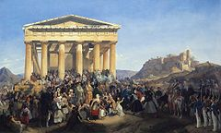](http://en.wikipedia.org/wiki/File:Otto's_entry_in_Athens.jpg)

**The Entry of King Otto in Athens, Peter von Hess, 1839.**

In 1827 **Ioannis Kapodistrias,** from Corfu, was chosen **as the first governor of the new Republic.**  However, following his assassination in 1831, **the Great Powers** installed **a monarchy under** Otto, **of the Bavarian House of Wittelsbach**.  In 1843 an uprising forced the king to grant a constitution and a representative assembly.

Due to his unimpaired authoritarian rule he was eventually dethroned in 1862 and a year later replaced by **Prince Wilhelm (William**) of Denmark, who took the name **George I** and brought with **him the Ionian Islands as a coronation gift from Britain.**  In 1877 **Charilaos Trikoupis**, who is credited with significant improvement of the country's infrastructure, curbed the power of the monarchy to interfere in the assembly by issuing the rule of vote of confidence to any potential prime minister.

Corruption and Trikoupis' increased spending to create necessary infrastructure like the C**orinth Canal** overtaxed the weak Greek economy, forcing the declaration of public insolvency in 1893 and to accept the imposition of an **International Financial Control** authority to pay off the country's debtors.  Another political issue in 19th-century Greece was uniquely Greek: the language question.  The Greek people spoke a form of Greek called **Demotic.**  Many of the educated elite saw this as a peasant dialect and were determined to restore the glories of Ancient Greek.

**The territorial evolution of Kingdom of Greece until 1947.**

Government documents and newspapers were consequently published in **Katharevousa (purified**) Greek, a form which few ordinary Greeks could read.  Liberals favoured recognising Demotic as the national language, but conservatives and the Orthodox Church resisted all such efforts, to the extent that, when the New Testament was translated into Demotic in 1901, riots erupted in Athens and the government fell (the Evangeliaka).  This issue would continue to plague Greek politics until the 1970s.

All Greeks were united, however, in their determination to liberate the Greek-speaking provinces of the Ottoman Empire.  Especially in Crete, a prolonged revolt in 1866–1869 had raised nationalist fervor.  When war broke out between Russia and the Ottomans in 1877, Greek popular sentiment rallied to Russia's side, but Greece was too poor, and too concerned of British intervention, to officially enter the war.  Nevertheless**, in 1881,** Thessaly and small parts of Epirus were ceded to Greece **as part of the Treaty of Berlin**, while frustrating Greek hopes of receiving Crete.

Greeks in Crete continued to stage regular revolts, and in 1897, the Greek government under **Theodoros Deligiannis**, bowing to popular pressure, **declared war on the Ottomans.  In** the ensuing Greco-Turkish War of 1897 the badly trained and equipped Greek army was defeated by the Ottomans.  Through the intervention of the Great Powers however, Greece lost only a little territory along the border to Turkey, while Crete was established as an autonomous state under Prince George of Greece.

### The 20th century and beyond

[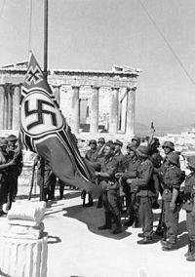](http://en.wikipedia.org/wiki/File:Bundesarchiv_Bild_101I-164-0389-23A,_Athen,_Hissen_der_Hakenkreuzflagge.jpg)

**German soldiers raising the Reichskriegsflagge over the Acropolis of Athens. It would be taken down in one of the first acts of the Greek Resistance.**

At the end of the Balkan Wars, the extent of Greece's territory and population had increased.  In the following years, the struggle between King Constantine I and charismatic Prime Minister **Eleftherios Venizelos** over the country's foreign policy on the **eve of World War I** dominated the country's political scene, and divided the country into two opposing groups.  During part of WWI, Greece had two governments; **a royalist pro-German government** in Athens and a **Venizelist pro-Britain** one in Thessaloniki.  The two governments were united in 1917, when Greece officially entered the war on the side of the **Triple Entente.**

In the aftermath of the First World War, Greece attempted further expansion into Asia Minor, a region with a large Greek population at the time, **but was defeated in the Greco-Turkish War of** **1919–1922,** which resulted in a **massive population exchange** between the two countries under the **Treaty of Lausanne**.  According to various sources, several hundred thousand **Pontic Greeks** died during this period, in what has sometimes been referred to as the **Pontic Greek Genocide.**

The following era was marked by instability, overshadowed by the massive task of incorporating **1.5 million Greek refugees from Turkey into Greek society**.  The Greek population in Istanbul dropped from 300,000 at the turn of the 20th century to around 3,000 in the city today.

Following the catastrophic events in Asia Minor, the monarchy was abolished via a referendum in 1924 and the **Second Hellenic Republic was** declared.  Premier Georgios Kondylis took power in 1935 and effectively abolished the republic by bringing back the monarchy via a referendum in 1935.  A coup d'état followed in 1936 and installed **Ioannis Metaxas** as the head of a dictatorial regime known as the 4th of August Regime.  Although a dictatorship, Greece remained on good terms with Britain and was not allied with the Axis.

On 28 October 1940 **Fascist Italy** **demanded the surrender of Greece,** but the Greek administration **refused** and in the following **Greco-Italian War,** Greece **repelled Italian forces into** Albania, giving **the Allies their first victory over Axis forces on land.**  The country would eventually fall to urgently dispatched German forces during the Battle of Greece.  The German occupiers nevertheless met serious challenges from the Greek Resistance.  **Over 100,000 civilians died of starvation during** **the winter of 1941–1942, and the great majority of Greek Jews were deported and murdered in** **Nazi concentration camps.**

After liberation, Greece experienced a **polarizing civil war between communist and anticommunist** forces, which led to economic devastation and severe social tensions between rightists and largely communist leftists for the next thirty years.  The next twenty years were characterized by marginalization of the left in the political and social spheres but also by rapid economic growth, propelled in part by the **Marshall Plan.**

**The Acropolis in Athens**

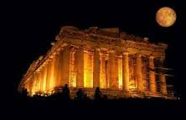

**The Parthenon, located on the Acropolis in Athens, is one of the most representative symbols of the culture and sophistication of the ancient Greeks. The Acropolis was formally proclaimed as the preeminent monument on the European Cultural Heritage list of monuments on 26 March 2007.**[**[5]**](http://en.wikipedia.org/wiki/Acropolis_of_Athens#cite_note-5)The **Parthenon** (Greek: Παρθενών) is a temple on the Athenian Acropolis, Greece, dedicated to the maiden goddess Athena, whom the people of Athens considered their patron deity. Its construction **began in 447 BC when the Athenian Empire was at the height of its power**. It was completed in 438 BC, although decoration of the building continued until 432 BC. **It is the most important** surviving building of Classic Greece, generally considered the culmination of the development of **the Doric order**. **Its decorative sculptures are considered some of the high points of Greek art.** The Parthenon is regarded as an enduring symbol of Ancient Greece, Athens democracy, western civilization **and one of the world's greatest cultural monuments**. **The Greek Ministry of Culture is currently carrying out a program of selective restoration and reconstruction to ensure the stability of the partially ruined structure.** After the Ottoman conquest, it was turned into a mosque in the early 1460s. On 26 September 1687, an Ottoman ammunition dump inside the building was ignited by Venetian bombardment. The resulting explosion severely damaged it.

T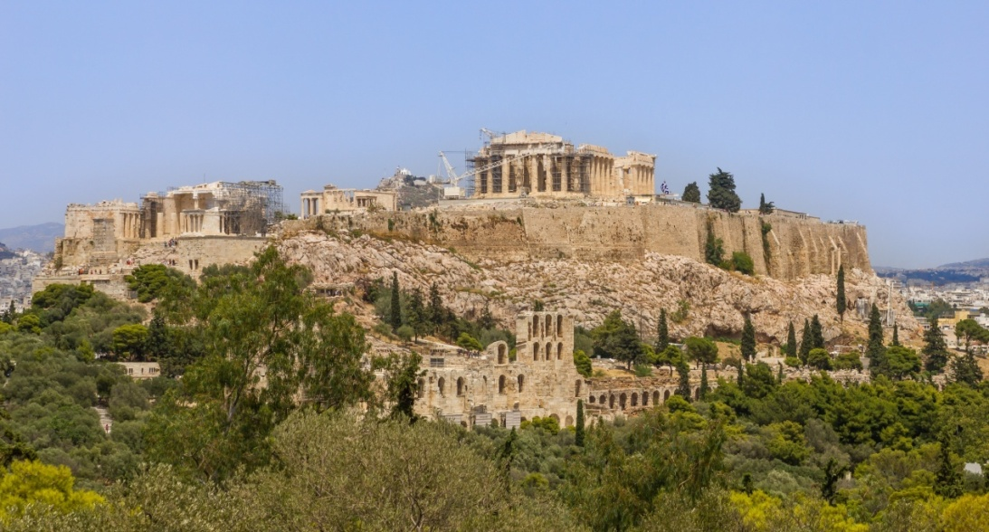he

**Acropolis of Athens** ([Greek](http://en.wikipedia.org/wiki/Greek_language): Ακρόπολη Αθηνών) is an ancient [citadel](http://en.wikipedia.org/wiki/Citadel) located on a high rocky outcrop above the city of [Athens](http://en.wikipedia.org/wiki/Athens) and containing the remains of several [ancient buildings](http://en.wikipedia.org/wiki/Ancient_Greek_architecture) of great architectural and historic significance, The word [acropolis](http://en.wikipedia.org/wiki/Acropolis) comes from the Greek words ἄκρον (akron, "edge, extremity") and πόλις (polis, "city").[[1]](http://en.wikipedia.org/wiki/Acropolis_of_Athens#cite_note-1) Although there are many other acropoleis in [Greece](http://en.wikipedia.org/wiki/Greece), the significance of the Acropolis of Athens is such that it is commonly known as "The Acropolis" without qualification.

**Mythology by Thomopoulos k Providas.**

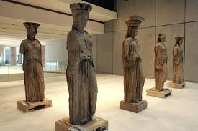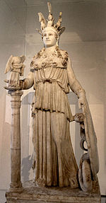The Muses in ancient Greek mythology were nine ancient deities. Apollo was their leader (Apollo Musagetes ) . Originally deities were nymphs of the mountain and water . Hesiod 's Theogony recounts : "The Mnemosyne in Pieria slept with his son Cronus and gave birth to these virgins who make us forget our suffering and soothe their pains . After a year when the seasons and months had completed their cycle and when I passed many days Mnemosyne gave birth to nine daughters ... that all enchanted by the music ... ". Their names are: Clio , Euterpe , Thalia , Melpomene , Terpsichore , Erato , Polymnia , Urania , Calliope .

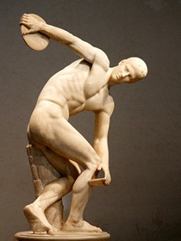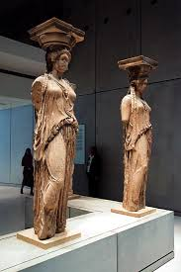

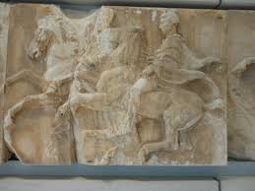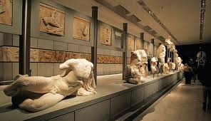

**In 1806, Thomas Bruce, 7th Earl of Elgin removed some of the surviving sculptures, with the permission of the Ottoman Empire. These sculptures, now known as the Elgin Marbles or the Parthenon Marbles, were sold in 1816 to the British Museum in London, where they are now displayed. Since 1983 (on the initiative of Culture Minister Melina Mercouri), the Greek government has been committed to the return of the sculptures to Greece.**

**Pictures by Kokkinou,Skreki,Karaxaliou**

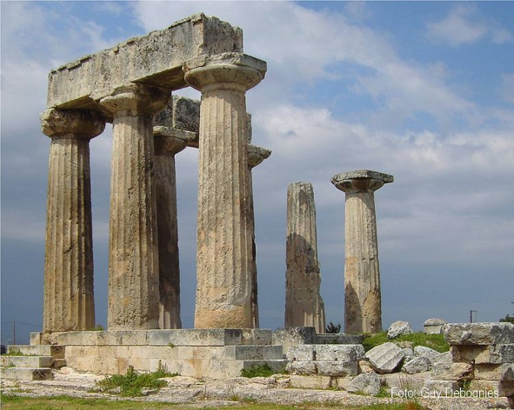**Ancient Corinth by Thomopoulos- Providas**

The temple of Apollo, is archaic temple in Ancient Corinth built with monolithic Doric columns. Of the 40 that existed survives today only seven standing prominently above the ruins of the ancient agora. The temple was built in 530 BC about. To support the roof and interior columns were along quite large in size alcove, which was divided into two rooms and also in the vestibule and opisthodomos they had in their front every two columns in antis. The church is a registered trademark of Corinth

### Ancient Knossos by Thomopoulos k,Haraugi Hatzivasilis

The Minoan palace is the main site of interest at Knossos, an important city in antiquity, which was inhabited continuously from the Neolithic period until the 5th c. AD. The palace was built on the Kephala hill and had easy access to the sea and the Cretan interior. According to tradition, it was the seat of the wise king Minos. The Palace of Knossos is connected with thrilling legends, such as the myth of the Labyrinth, with the Minotaur, 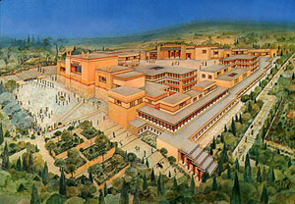

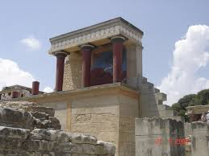The first excavations were made in 1878 by Minos Summer Herakleion . Followed by excavations carried out by the Englishman Sir Arthur Evans (1900-1913 and 1922-1930) , who uncovered the entire palace.  
The oldest signs of habitation in the area of the palace dating back **to the Neolithic period** (7000-3000 BC ) . The occupation continues in the Pre period (3000-1900 BC ) , after which the area was leveled for the construction of a large palace . The first palace was destroyed, probably by an earthquake in 1700 BC .

A Second magnificent palace was built on the ruins of the old. After partially destroyed around 1450 BC, **the Mycenaeans settled at Knossos**. The palace was finally destroyed about 1350 BC by fire. The area covered again from the late Mycenaean period until Roman times . It was a multi-storey building covering an area of 20,000 sq.m. Impressive is the variety of building materials, colored mortar, the marble decorations and frescoes that adorn rooms and corridors . High technical knowledge of the Minoans confirm original architectural and structural features such as skylights and polythyra , use beams to reinforce the masonry , and the complex drainage and water supply network .

Knossos flourished for approximately two thousand years. It had large palace buildings, extensive workshop installations and luxurious rock-cut cave and tholos tombs. As a major centre of trade and the economy, Knossos maintained ties with the majority of cities in the Eastern Mediterranean.

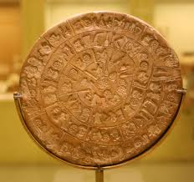The **Phaistos Disc** (also spelled **Phaistos Disk**, **Phaestos Disc**) is a disk of fired [clay](http://en.wikipedia.org/wiki/Clay) from the [Minoan](http://en.wikipedia.org/wiki/Minoan_civilization) palace of [Phaistos](http://en.wikipedia.org/wiki/Phaistos) on the Greek island of [Crete](http://en.wikipedia.org/wiki/Crete), possibly dating to the middle or late Minoan [Bronze Age](http://en.wikipedia.org/wiki/Bronze_Age) ([2nd millennium BC](http://en.wikipedia.org/wiki/2nd_millennium_BC)). It is about 15 cm (5.9 in) in diameter and covered on both sides with a spiral of stamped symbols. Its purpose and meaning, and even its original geographical place of manufacture, remain disputed, making it one of the most famous mysteries of [archaeology](http://en.wikipedia.org/wiki/Archaeology). This unique object is now on display at the [archaeological museum](http://en.wikipedia.org/wiki/Iraklion_Archaeological_Museum) of [Heraklion](http://en.wikipedia.org/wiki/Heraklion).

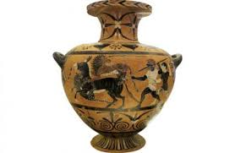

An amphora vase with an oval body with vertical grip bilaterally. Used to store wine and sometimes oil. The name comes from the amphora bi adverb and verb ferein. **The jars were invented in ancient Greece and adopted by the Romans** as a primary means of transportation and storage of wine, oil olives, grain, fish.

**By Thomopoulos**

**Topography**

**By Vallios -Doulogeris**

[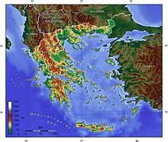](http://en.wikipedia.org/wiki/File:Greece_topo.jpg)

Greece features a vast number of **islands,** between 1,200 and 6,000, depending on the definition, 227 of which are inhabited.  **Crete** is the largest and most populous island; **Euboea,** separated from the mainland by the 60m-wide Euripus Strait, is the second largest, followed by **Rhodes** and **Lesbos.**

**The Greek islands** are traditionally grouped into the following clusters: The **Argo-Saronic Islands** in the Saronic gulf near Athens, **the Cyclades,** a large but dense collection occupying the central part of the Aegean Sea, the **North Aegean** islands, a loose grouping off the west coast of Turkey, **the Dodecanese**, another loose collection in the southeast between Crete and Turkey, **the Sporades**, a small tight group off the coast of northeast **Euboea,** and the **Ionian Islands**, located to the west of the mainland in the Ionian Sea.

Eighty percent of Greece consists of mountains or hills, making the country **one of the most** **mountainous in Europe.**  **Mount Olympus**, **the mythical abode of the Greek Gods**, culminates at Mytikas peak 2,917 m (9,570 ft), the highest in the country.  Western Greece contains a number of **lakes and wetlands** and is dominated by the **Pindus mountain range**.  The Pindus, a continuation of the Dinaric Alps, reaches a maximum elevation of 2,637 m (8,652 ft) at Mt. Smolikas (the second-highest in Greece) and historically has been a significant barrier to east-west travel.

The Pindus range continues through the central Peloponnese crosses the islands of Kythera and Antikythera and finds its way into southwestern Aegean, in the island of Crete where it eventually ends.  The islands of the Aegean are peaks of underwater mountains that once constituted an extension of the mainland.  Pindus is characterized by its high, steep peaks, often dissected by numerous canyons and a variety of other landscapes.

|  |
| --- |
|  |

**[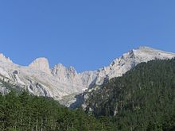](http://en.wikipedia.org/wiki/File:Mytikas.jpg) The spectacular Vikos Gorge, part of the Vikos-Aoos National Park in the Pindus range, is listed by the Guinness book of World Records as the deepest gorge in the world.  Another notable** formation are the **Meteora** rock pillars,where medieval Greek Orthodox **monasteries have been built.**

Northeastern Greece features another high-altitude mountain range, the **Rhodope range,** spreading across the region of East Macedonia and Thrace; **this area is covered with vast, thick, ancient forests, including the famous Dadia forest in the Evros regional unit, in the far northeast of the country.**

**Extensive plains are primarily located in the regions of Thessaly, Central Macedonia and Thrace.**  They constitute key economic regions as they are among the few arable places in the country.  Rare **marine species such as the Pinniped Seals and the Loggerhead Sea Turtle live in the seas** **surrounding mainland Greece, while its dense forests are home to the endangered brown bear, the** **lynx, the Roe Deer and the Wild Goat.**

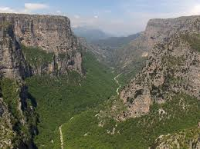Vikos Gorge

**By Danai Lazaridi**

**Vikos Gorge**, located 30 km northwest of Ioannina is the **deepest canyon in the world, according to the book** **Guinness** . It forms the core of the National Park of Vikos- Aoou, in this district a wide variety **of rare species of flora and fauna finds refuge**The canyon has a length of 20 km and in many parts of the depth exceeds 1,000 meters. The tributary Aoou, Boidomatis, who runs, is only seasonal water   
  
Vikos was created after intense geological upheavals during geological time. **The earliest traces of human activity in the area were identified by the 40,000** BC . The flora found in the region of the gorge is a very large variety. Typically, up to the early 20th century the gorge herbs were used by practitioners, the so-called «Vikogiatrous «for therapeutic purposes. **Vikos Gorge is a popular route for travelers, the duration of the tour for an experienced team takes no more than 5 hours, offering unique images.** From the village Vradeto (Beloi position), but also from Oxia the view of the canyon is panoramic .In the gorge any human activity associated with husbandry and of course logging is strictly forbidden.

THE Samaria GORGE

**By D. LAZARIDI**

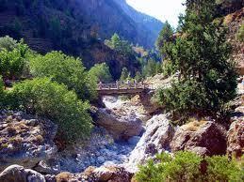**The Samaria Gorge in Crete is located in the southern part of the prefecture of Chania. With a** **length of 18 km, is probably the longest gorge in Europe after the canyon Verdi in France**. It is a National Park of Greece since 1962 and is home to many endemic species of birds and animals, the **most famous of which is the Cretan goat known as ibex.** The name comes from the abandoned village of Samaria, which in turn owes its name to the Church of Mary Osias. During the Ottoman rule was hiding rebels and the local population. The climate of Greece is primarily Mediterranean, featuring mild, wet winters and hot, dry summers.  This climate occurs at all coastal locations, including Athens, the Cyclades, the Dodecanese, Crete, the Peloponnese, the Ionian Islands and parts of the Central Continental Greece region

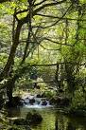

The Pindus mountain range strongly affects the climate of the country, as areas to the west of the range are considerably wetter on average (due to greater exposure to south-westerly systems bringing in moisture) than the areas lying to the east of the range (due to a rain shadow effect).The mountainous areas of Northwestern Greece (parts of Epirus, Central Greece, Thessaly, Western Macedonia) as well as in the mountainous central parts of Peloponnese – including parts of the regional units of Achaea, Arcadia and Laconia – feature an Alpine climate with heavy snowfalls.  The inland parts of northern Greece, in Central Macedonia and East Macedonia and Thrace feature a temperate climate with cold, damp winters and hot, dry summers with frequent thunderstorms.  Snowfalls occur every year in the mountains and northern areas, and brief snowfalls are not unknown even in low-lying southern areas, such as Athens.

**Greek cuisine**

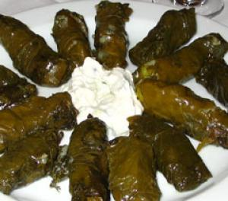**By Lazaridi Danai**

The cuisine of Greece has many traditional dishes. It is known for its superb wine and wonderful olive oil .**Greek cuisine** is a [**Mediterranean cuisine**](http://en.wikipedia.org/wiki/Mediterranean_cuisine)**,** sharing numerous characteristics with Middle Easterncuisines of the region. Contemporary [Greek](http://en.wikipedia.org/wiki/Greece) cookery makes wide use of olive oil, vegetables and herbs, grains and bread, [wine](http://en.wikipedia.org/wiki/Wine), [fish](http://en.wikipedia.org/wiki/Fish_%28food%29), and various meats, including [lamb](http://en.wikipedia.org/wiki/Lamb_and_mutton), [poultry](http://en.wikipedia.org/wiki/Poultry), [rabbit](http://en.wikipedia.org/wiki/Rabbit) and [pork](http://en.wikipedia.org/wiki/Pork). Also important are [olives](http://en.wikipedia.org/wiki/Olive), [cheese](http://en.wikipedia.org/wiki/Cheese), [eggplant](http://en.wikipedia.org/wiki/Eggplant) (aubergine), [zucchini](http://en.wikipedia.org/wiki/Zucchini) (courgette), and [yogurt](http://en.wikipedia.org/wiki/Yogurt). Greek desserts are characterized by the dominant use of nuts and honey. Some dishes use [filo](http://en.wikipedia.org/wiki/Phyllo) pastry.[Mezés](http://en.wikipedia.org/wiki/Meze) (μεζές) is a collective name for a variety of small dishes, typically served with wines or anise-flavored liqueurs as [ouzo](http://en.wikipedia.org/wiki/Ouzo) or homemade [tsipouro](http://en.wikipedia.org/wiki/Tsipouro). Orektika is the formal name for appetizers and is often used as a reference to eating a first course of a cuisine other than Greek cuisine. [Dips](http://en.wikipedia.org/wiki/Dip_%28food%29) are served with bread loaf or [pita](http://en.wikipedia.org/wiki/Pita) bread. In some regions, dried bread (paximadhi) is softened in water. Greek cuisine has a long tradition and its flavors change with the season and its geography.Greek cookery, **historically a forerunner of Western cuisine,** spread its culinary influence - via ancient Rome - throughout Europe and beyond. It has influences from the different people's cuisine that Greeks have interacted with over the centuries, as evidenced by several types of sweets and cooked foods.

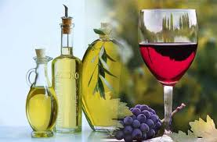**It was** [**Archestratos**](http://en.wikipedia.org/wiki/Archestratos) **in 320 B.C. who wrote** **the first cookbook in history**. **Greece has a culinary tradition of some 4,000 years.** [**Ancient Greek cuisine**](http://en.wikipedia.org/wiki/Ancient_Greek_cuisine) **was characterized by its frugality and was founded on the "Mediterranean triad":** [**wheat**](http://en.wikipedia.org/wiki/Wheat)**,** [**olive oil**](http://en.wikipedia.org/wiki/Olive_oil)**, and** [**wine**](http://en.wikipedia.org/wiki/Wine)**,** with meat being rarely eaten and fish **being more common.** This trend in Greek diet continued in Roman and Ottoman times and changed only fairly recently when technological progress has made meat more available. Wine and olive oil have always been a central part of it and **the spread of grapes and olive trees in the Mediterranean and further afield is correlated with Greek colonization.** The [Byzantine cuisine](http://en.wikipedia.org/wiki/Byzantine_cuisine) was similar to the classical cuisine including however new ingredients that were not available before, like caviar, nutmeg and lemons, basil, with fish continuing to be an integral part of the diet. Culinary advice was influenced by the theory of humors, first put forth by **the ancient Greek doctor** [**Claudius Aelius Galenus**](http://en.wikipedia.org/wiki/Galen). Byzantine cuisine benefited from Constantinople’s position as a global hub of the spice trade.

**Greek customs and traditions**

**By Myrto Vazaka-Modena**

**Sophie Gouskou**

**Christine Konstantinou**

Greece plays host to religious festivals with deeply rooted customs and centuries-old traditions all year round. One of the greatest celebrations of Christianity is **Easter.** The faithful Christians all over Greece follow the Holy Week ritual devoutly, giving themselves body and soul into the culmination of the Passion of Christ and finally rejoicing in His Resurrection. Let’s take a deeper insight into ancient-old rituals and traditions…

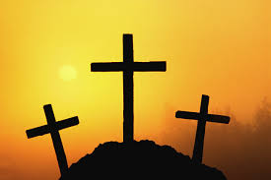**Easter**

Considered the most important holiday on Greek calendar and one of the richest in folklore, the celebration of Orthodox Easter (**Pascha)** is unique throughout Greece. From Crete to Macedonia, Easter customs become a herald of the spirit’s and nature’s rebirth, while Easter celebrations constitute a vivid aspect of the folk culture, rich in symbolism.   
  
The preparations for the celebration of the Resurrection start on Holy Thursday. On that day, housewives traditionally prepare special cakes named tsourekia, biscuits and red color eggs. The use of egg is a symbol of rebirth while the red color stands for the blood of Christ. In the past, in many households, people used to place the first red egg on the icon stand of the house in order to cast out evil   
  
Friday is the most sacred day of the Holy Week, the day of the culmination of the passion of Christ with the deposition from the cross and Christ’s burial. Because it is a day of mourning, housewives avoid doing housework. Women and children go to church to decorate the Epitaph (Bier of Christ) with flowers, while in the evening the Epitaph procession takes place. On Saturday morning, preparations start for the festive dinner and a special soup is cooked called “maghiritsa”.   
  
Shortly before midnight, people gather in church holding white candles which they light with the “Holy Light” distributed by the priest. When the latter chants “Christ is risen” (Christos Anesti), people exchange wishes and the so-called “Kiss of Love”. With the “Holy Light” of the candles they make three times the sign of the cross on the door post over the front door of their houses for good luck. Then they all gather around the table, they crack red eggs and wish one another Christos Anesti. On Sunday morning, mainly in Greek countryside, lamb is prepared on the spit and people eat and dance usually until late at night.

**Travelling**   
[**Travelling in Greece during Greek Orthodox Easter**](http://www.visitgreece.gr/portal/site/eot/menuitem.7f0d4e449429307c12596610451000a0/?vgnextoid=8352570850527210VgnVCM100000460014acRCRD&lang_choosen=en) **offers visitors the opportunity to enjoy the Greek countryside and to experience some traditional and festive atmosphere.**  
• Visiting the Ionian [island of **Corfu** during Easter](http://www.digitalcorfu.com/default.aspx?lang=en) is ideal, since [the town hosts](http://www.visitgreece.gr/portal/site/eot/menuitem.f6461d577e1bafc0ace49610451000a0/?vgnextoid=dcbb328fbf5f8110VgnVCM100000460014acRCRD&lang_choosen=en) the most splendid and melodic celebrations in the country, with the city’s philharmonics in full action. On Holy Saturday morning, one of the highlights is the dropping of ceramic pots "botides" full of water from the windows on the cobbled streets.

• In the Aegean [**island of Chios**](http://www.chios.gr/guide/en/index.htm)**,** another custom takes place where residents of the [village of Vrontados](http://www.chiosnet.gr/tourism/chios_vrontados.htm) revive the tradition of "the rocket war." After Resurrection, Vrontados breaks into a pandemonium of fireworks lighting up the midnight sky.  
  
• In the Cycladic [**island of Tinos**](http://www.tinos.gr/index_en.html)**,** on Holy Friday, parishioners of both Orthodox and Catholic churches carry the Holy Sepulchers of their churches to the port, where they join forces in chanting hymns, before each Sepulcher follows its own itinerary through neighborhoods.

**CHRISTMAS**

**The festive period lasts from 30 November to 6 January (Epiphany) on the** [**Greek calendar**](http://en.wikipedia.org/wiki/Public_holidays_in_Greece)**. 25 and 26 December is a** [**public holiday in Greece**](http://en.wikipedia.org/wiki/Public_holidays_in_Greece)**. In** [**Greek**](http://en.wikipedia.org/wiki/Greek_Language)**, Christmas is known as Christougena (Χριστούγεννα) and people wish Merry Christmas to each other saying Kala Christougena . shops have decorations and lights. Presents are placed under the Christmas tree and are opened on 1 January, St Basil's Day.**

**[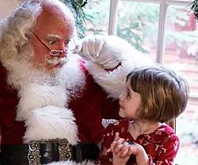](http://en.wikipedia.org/wiki/File:Santa_Claus_portrayed_by_Jonathan_Meath_4.jpg)Tradition of St Basil**

**In Greek tradition,** [**Basil’s (of Caesarea)**](http://en.wikipedia.org/wiki/Basil_of_Caesarea) **name was given to Father Christmas and is supposed to visit children and give presents on 1 January (when Basil's memory is celebrated), The Christmas meal usually includes lamb or pork and desserts such as** [**kourabies**](http://en.wikipedia.org/wiki/Kourabies) **(κουραμπιές) and** [**melomakarona**](http://en.wikipedia.org/wiki/Melomakarona)**)(μελομακάρονα). Other Christmas and New Year foods include 'Baklava' (sweet pastry), Kataifi (pastry), and Temples (a kind of fried pastry).**

**On December 24 and 23 ,housewives make the Christmas cake with a cross in the middle and avgokouloures which are offered to the elderly and children. Children sing carols from house to house either before or on Christmas Day. People go to church early in the morning of Christmas of 25 December. The "pork batches", served with wine to open the appetite, and "thick" which is done by Eve, which is boiled pork with plenty of lemon, which are left to clot overnight. The pork-food is the hallmark of Greek Christmas.**

**In many Greek cities and ports like** [**Thessaloniki**](http://en.wikipedia.org/wiki/Thessaloniki)**,** [**Volos**](http://en.wikipedia.org/wiki/Volos)**,** [**Patra**](http://en.wikipedia.org/wiki/Patras)**, the** [**Greek Islands**](http://en.wikipedia.org/wiki/List_of_islands_of_Greece) **the traditional Christmas** [**boat**](http://en.wikipedia.org/wiki/Boat) **id decorated. And in many central squares of the country a big Christmas tree is decorated too.many Christmas festivals take place. A well known Christmas Festival in Greece is "Ρουγκατσάρια" Rugatsariα, where all the residents of the city of** [**Castoria**](http://en.wikipedia.org/wiki/Kastoria) **are delivered in a separate** [**Dionysian**](http://en.wikipedia.org/wiki/Dionysos) **revelry, with the accompaniment of folk melodies**

**[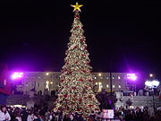](http://en.wikipedia.org/wiki/File:Athens_Christmas_Tree.jpg)The largest Christmas tree in Europe is lit in Syntagma Square, the location of the capital's Christmas village, where little elf houses sell candy and children can take part in a number of activities. There is no limit to Christmas fun in Greece!**

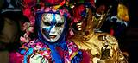

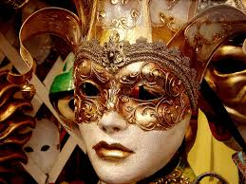

**Carnival**

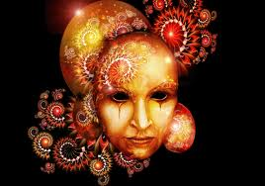If you love to party then Athens between Sunday 24th January and Sunday 14th February is the place for you.It’s the three weeks of Apokries, the Greek carnival. **The festivities have their origins in ancient Greece and the celebrations in honour of Dionysus (Bachus), the god of wine and joy, that used to take place to celebrate the end of Winter.**Children almost universally follow the tradition of dressing up but Apokries is a good excuse for fun for the grown up too. Home parties are organised every weekend, reaching their peak in the third weekend of the period and all bars and clubs are decorated to welcome the dressed up party goers. **Plaka** is the epicentre of action during this last weekend with thousands of people gathering there and following a self styled parade of the costumed masses.   
**The celebrations differ around Greece depending on the particular local traditions.**

**• Patras: The King of Greek Carnivals**The port city of [Patras](http://www.e-patras.gr/portal/web/common/home) hosts the biggest carnival in Greece, and one of the biggest in Europe. The ["king" of Greek carnivals](http://www.visitgreece.gr/portal/site/eot/menuitem.f6461d577e1bafc0ace49610451000a0/?vgnextoid=8e77029f53ddd210VgnVCM100000010a0a0aRCRD&lang_choosen=en) begins in January with an announcement by the town crier, and reaches its peak in the last weekend of carnival. Patras carnival features a variety of events: balls, parades, street theatre, and much more. The carnival reaches its apogee on the last weekend of Triodion: Saturday evening brings the walking parade (with participants taking the streets holding torches), while the phantasmagorical floral, artistic, and satirical floats parade on Sunday, with the Carnival King and Queen in all their splendor. But Patras carnival is mostly the thousands carnival-goers of all ages, participating spontaneously to the events taking place everywhere in the city -homes, bars, streets - turning the whole city into a gigantic party.   
  
**• Xanthi: The Folk Carnival**  
The Thracian city of [Xanthi](http://www.cityofxanthi.gr/) hosts one of the most popular carnivals in the country. [Xanthi carnival](http://www.carnivalx.gr/index.php?lang=en) started in 1966 as an urban event but has incorporated many traditional elements, based on the city’s multicultural character that renders it the most folklore of urban carnivals. The highlight is the [Folk Parade](http://www.visitgreece.gr/portal/site/eot/menuitem.f6461d577e1bafc0ace49610451000a0/?vgnextoid=402d4e08c95ed210VgnVCM100000010a0a0aRCRD&lang_choosen=en) on Saturday before Ash Monday: bringing together cultural associations from all over Greece, the troupes go singing and dancing through the neighborhoods of the picturesque [Old Town](http://www.cityofxanthi.gr/index.php/en/our-town/old-town) and merge in an all-night Balkan folk music fiesta in the main square. Cheesefare Sunday leads to the custom of Burning the tzaros, a human effigy placed on top of a pile of brushwood.   
  
**• The "Old Men" of Skyros**The carnival in the Aegean island of [Skyros](http://www.inskyros.gr/InSkyrosNew/indexen.htm) comes alive with the [sounds of clanging goat bells](http://skyroson.gr/skyros/content/view/712/110/). These are worn around the waists of the island men who take part in the carnival playing the role of geros (old man), a figure dressed in a hooded black cape and hanging goat skin. The "old men" run through the streets individually or in groups, singing, dancing and making as much noise as possible, while locals and guests must always toast, drink and dance with the "old men".   
  
**• “Flour War” in Galaxidi**In Fokida Prefecture, the town of [Galaxidi](http://www.fokida.gr/site/en_US/categories/prefokida/municipalities/Galaxidi.csp) is one of Greece’s top destinations especially during carnival season. The picturesque small town impresses visitors with its tranquil charm and its rich maritime heritage, notably the old captains’ mansions, the so-called kapetanospita. During Carnival, the town revives the [unique custom of "alevromoutzouromata"](http://www.fokida.gr/site/en_US/categories/prefokida/municipalities/Galaxidi/diffContent/cultural_events/aleuromoutzouroma.csp) dating back to the heyday of the town’s merchant fleet, as a fun event for departing sailors at the end of the Carnival. On Clean Monday, Galaxidi is transformed into a battlefield as hundreds of people pelt mercilessly one another with large quantities of flour and dance around the fires – the most daring even jump over them!   
Traditionally, Apokries begin ten weeks before Greek Orthodox Easter and culminates on the weekend before "Clean Monday," (Ash Monday) the first day of Lent. "Apokria", literally means “goodbye” to the period of meat-eating, or abstinence from meat (Apo-kreo, meaning away from meat).   
Carnival officially begins on a Saturday evening with the "opening of the Triodion," the Lenten Triodion, as it is called - which a liturgical book of the Orthodox Church that contains hymns with three odes and begins to be chanted on the Sunday of the Publican and the Pharisee through Holy Saturday.   
The following week is a fast-free week until [Meatfare Sunday](http://lent.goarch.org/judgement/learn/) which is the last day before Easter for eating meat. On Thursday of this week which is known as Tsiknopempti- Charred, Smoky or [Barbeque Thursday](http://greekfood.about.com/b/2011/02/23/tsiknopempti-charred-thursday.htm)- because of the smell of the grilled meat in the air, family and friends gather in taverns or homes to eat large quantities of charred meat and celebrate, just ten days before the beginning of Lent.   
The last Sunday of the Carnival period is known as [Cheesefare Sunday](http://lent.goarch.org/forgiveness/learn/) or Tyrofagos as only dairy products can be consumed on this day. Cheesefare Sunday is the final day of pre-Lent, as the Monday following -known as Clean or Ash Monday- marks the beginning of Great Lent. During the weekend preceding Clean Monday, carnival celebrations around Greece culminate with vigorous parades, masquerade parties, reviving many traditional customs in different parts of the country, and proving that carnival in Greece is closely related to the cultural heritage of each region.  
Clean (or Ash) Monday is a public holiday in Greece which marks the end of the carnival festive season and the start of Lent or the period of fasting until Easter. Weather permitting, people spend Clean Monday outdoors, organizing picnics while children fly kites. Since it marks the beginning of the fasting period special food is eaten on this day. Eating red meat, poultry, fish or dairy products is not permitted. However, a host of other dishes and delicacies is available: lagana (a special unleavened bread eaten only on this day), taramasalata ([a fish roe spread](http://www.kerasma.gr/default.asp?entryID=469&pageID=101&langid=2&pageCode=&tablePageID=14&pageNo=1&direction=asc&orderby=&f_occasion_sub=3&pages=1)), dolmadakia ([vine leaves stuffed with rice](http://greekfood.about.com/b/2007/02/13/rice-stuffed-grape-leaves-dolmathakia-yialantzi.htm)), [grilled octopus](http://www.kerasma.gr/default.asp?entryID=475&pageID=101&langid=2&pageCode=&tablePageID=14&pageNo=1&direction=asc&orderby=&f_occasion_sub=3&pages=1), gigantes plaki ([oven-baked broad beans](http://greekfood.about.com/od/maindishes/r/gigantesplaki.htm)), seafood salads and shellfish as well as a special semolina pudding known as [halvas](http://www.kerasma.gr/default.asp?entryID=530&pageID=101&langid=2&pageCode=&tablePageID=14&pageNo=2&direction=asc&orderby=&f_occasion_sub=3&pages=1) are just some of them.

**EUROPE**

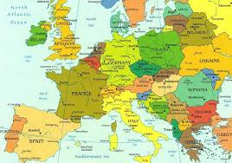**Europe** is one of the world's seven [continents](http://en.wikipedia.org/wiki/Continent). Comprising the westernmost [peninsula](http://en.wikipedia.org/wiki/Peninsula) of [Eurasia](http://en.wikipedia.org/wiki/Eurasia), Europe is generally [divided from Asia](http://en.wikipedia.org/wiki/Borders_of_the_continents#Europe_and_Asia) by the [watershed divides](http://en.wikipedia.org/wiki/Drainage_divide) of the [Ural](http://en.wikipedia.org/wiki/Ural_Mountains) and [Caucasus](http://en.wikipedia.org/wiki/Caucasus_Mountains) Mountains, the [Ural River](http://en.wikipedia.org/wiki/Ural_River), the [Caspian](http://en.wikipedia.org/wiki/Caspian_Sea) and [Black](http://en.wikipedia.org/wiki/Black_Sea) Seas, and the [waterways](http://en.wikipedia.org/wiki/Bosporus) connecting the [Black](http://en.wikipedia.org/wiki/Black_Sea) and [Aegean](http://en.wikipedia.org/wiki/Aegean_Sea) Seas. Europe is bordered by the [Arctic Ocean](http://en.wikipedia.org/wiki/Arctic_Ocean) to the north, the [Atlantic Ocean](http://en.wikipedia.org/wiki/Atlantic_Ocean) to the west, the [Mediterranean Sea](http://en.wikipedia.org/wiki/Mediterranean_Sea) to the south, and the Black Sea and connected waterways to the southeast.

**Europe, in particular** [**Ancient Greece**](http://en.wikipedia.org/wiki/Ancient_Greece) **and** [**Ancient Rome**](http://en.wikipedia.org/wiki/Ancient_Rome)**, is the birthplace of** [**Western culture**](http://en.wikipedia.org/wiki/Western_culture)**. It played a predominant role in global affairs from the 15th century onwards, especially after the beginning of** [**colonialism**](http://en.wikipedia.org/wiki/Colonialism)**. Between the 16th and 20th centuries, European nations controlled at various times** [**the Americas**](http://en.wikipedia.org/wiki/European_colonisation_of_the_Americas)**,** [**most of Africa**](http://en.wikipedia.org/wiki/Colonisation_of_Africa)**,** [**Oceania**](http://en.wikipedia.org/wiki/Oceania)**, and large portions of Asia. The** [**Industrial Revolution**](http://en.wikipedia.org/wiki/Industrial_Revolution)**, which began in** [**Great Britain**](http://en.wikipedia.org/wiki/Great_Britain) **around the end of the 18th century, gave rise to radical economic, cultural, and social change in Western Europe, and eventually the wider world. Demographic growth meant that, by 1900, Europe's share of the world's population was 25%.**

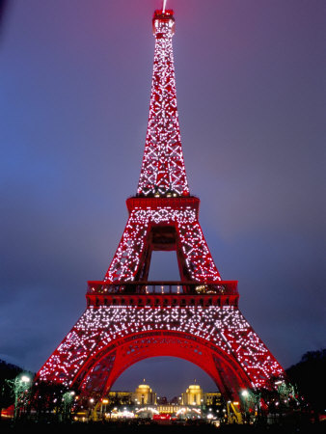France

France officially the French Republic ([French](http://en.wikipedia.org/wiki/French_language): République française), is a sovereign country in [Western Europe](http://en.wikipedia.org/wiki/Western_Europe) that includes [overseas regions and territories](http://en.wikipedia.org/wiki/Overseas_departments_and_territories_of_France). [Metropolitan France](http://en.wikipedia.org/wiki/Metropolitan_France) extends from the [Mediterranean Sea](http://en.wikipedia.org/wiki/Mediterranean_Sea) to the [English Channel](http://en.wikipedia.org/wiki/English_Channel) and the [North Sea](http://en.wikipedia.org/wiki/North_Sea), and from the [Rhine](http://en.wikipedia.org/wiki/Rhine) to the [Atlantic Ocean](http://en.wikipedia.org/wiki/Atlantic_Ocean). It is one of only three countries (besides [Morocco](http://en.wikipedia.org/wiki/Morocco) and [Spain](http://en.wikipedia.org/wiki/Spain)) to have both Atlantic and Mediterranean coastlines. Due to its shape, it is often referred to in French as Hexagone

**Germany**

**Germany** officially the **Federal Republic of Germany**

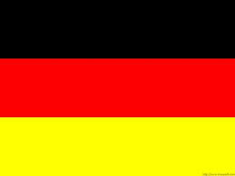A [federal](http://en.wikipedia.org/wiki/Federation) [parliamentary republic](http://en.wikipedia.org/wiki/Parliamentary_republic) in [western](http://en.wikipedia.org/wiki/Western_Europe)-[central Europe](http://en.wikipedia.org/wiki/Central_Europe). The country consists of [16 states](http://en.wikipedia.org/wiki/States_of_Germany) and its capital and [largest city](http://en.wikipedia.org/wiki/List_of_cities_in_Germany_by_population) is [**Berlin**](http://en.wikipedia.org/wiki/Berlin)**.** Germany covers an area of 357,021 square kilometres (137,847 sq mi) and has a largely temperate seasonal climate. With 80.6 million inhabitants, it is **the most populous** member state in the [European Union](http://en.wikipedia.org/wiki/European_Union). Germany is the major economic and political power of the European continent and a historic leader in many cultural, theoretical and technical fields.

Italy

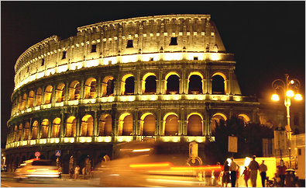**Italy** officially the **Italian Republic is a** [unitary](http://en.wikipedia.org/wiki/Unitary_state) [parliamentary republic](http://en.wikipedia.org/wiki/Parliamentary_republic) in [Southern Europe](http://en.wikipedia.org/wiki/Southern_Europe). To the north, Italy borders [France](http://en.wikipedia.org/wiki/France), [Switzerland](http://en.wikipedia.org/wiki/Switzerland), [Austria](http://en.wikipedia.org/wiki/Austria), and [Slovenia](http://en.wikipedia.org/wiki/Slovenia), and is approximately delimited by the [Alpine watershed](http://en.wikipedia.org/wiki/Alps), enclosing the [Po Valley](http://en.wikipedia.org/wiki/Po_Valley) and the [Venetian Plain](http://en.wikipedia.org/wiki/Venetian_Plain). To the south, it consists of the entirety of the [Italian Peninsula](http://en.wikipedia.org/wiki/Italian_Peninsula) and the two biggest [Mediterranean islands](http://en.wikipedia.org/wiki/Mediterranean_islands) of [Sicily](http://en.wikipedia.org/wiki/Sicily) and [Sardinia](http://en.wikipedia.org/wiki/Sardinia).

Italian territory also includes the islands of [Pantelleria](http://en.wikipedia.org/wiki/Pantelleria), 60 km (37 mi) east of the Tunisian coast and 100 km (62 mi) southwest of Sicily, and [Lampedusa](http://en.wikipedia.org/wiki/Lampedusa), at about 113 km (70 mi) from Tunisia and at 176 km (109 mi) from Sicily, in addition to many other smaller islands. The sovereign states of [San Marino](http://en.wikipedia.org/wiki/San_Marino) and the [Vatican City](http://en.wikipedia.org/wiki/Vatican_City) are [enclaves](http://en.wikipedia.org/wiki/Enclave_and_exclave) within Italy, while [Campione d'Italia](http://en.wikipedia.org/wiki/Campione_d%27Italia) is an Italian [exclave](http://en.wikipedia.org/wiki/Enclave_and_exclave) in Switzerland. Italy covers an area of 301,338 km2 (116,347 sq mi) and has a largely [temperate climate](http://en.wikipedia.org/wiki/Temperate_climate). With 60 million inhabitants, it is the [5th most populous country in Europe](http://en.wikipedia.org/wiki/List_of_European_countries_by_population). Italy is also the [4th-largest](http://en.wikipedia.org/wiki/List_of_sovereign_states_in_Europe_by_GDP_%28PPP%29) economy in the European Union, 3rd in the [Eurozone](http://en.wikipedia.org/wiki/Eurozone) and [9th](http://en.wikipedia.org/wiki/List_of_countries_by_GDP_%28nominal%29) in the world (IMF, 2012).

|  |
| --- |
| **uk.jpgUnited Kingdom**  **The United Kingdom of Great Britain and Northern Ireland, commonly known as the United Kingdom (UK) or Britain , is a** [**sovereign state**](http://en.wikipedia.org/wiki/Sovereign_state) **located off the north-western coast of** [**continental Europe**](http://en.wikipedia.org/wiki/Continental_Europe)**. The country includes the island of** [**Great Britain**](http://en.wikipedia.org/wiki/Great_Britain) **(a term sometimes loosely applied to the whole state), the north-eastern part of the island of** [**Ireland**](http://en.wikipedia.org/wiki/Ireland)**, and many smaller islands.** [**Northern Ireland**](http://en.wikipedia.org/wiki/Northern_Ireland) **is the only part of the UK that shares a** [**land border**](http://en.wikipedia.org/wiki/Republic_of_Ireland_%E2%80%93_United_Kingdom_border) **with another state: the** [**Republic of Ireland**](http://en.wikipedia.org/wiki/Republic_of_Ireland)**. The UK is surrounded**  **by the Atlantic Ocean with the** [**North Sea**](http://en.wikipedia.org/wiki/North_Sea) **in the east,**  **the** [**English Channel**](http://en.wikipedia.org/wiki/English_Channel) **in the south and the** [**Irish Sea**](http://en.wikipedia.org/wiki/Irish_Sea) **in the west.**  **[http://t1.gstatic.com/images?q=tbn:ANd9GcS3fVAoaPeY36VudDXcVzC1PGZ1Ffh5QsHhC6TtKFiceRwEW-rFFse0NJU](http://www.google.gr/imgres?imgurl=http://www.freeworldmaps.net/europe/united-kingdom/england/england.jpg&imgrefurl=http://www.freeworldmaps.net/europe/united-kingdom/england/map.html&usg=__PtgAybhvt5I2LBVqcU5rV5B5PoM=&h=958&w=750&hl=el&start=17&zoom=1&tbnid=napx7wRSd_Ge5M:&tbnh=148&tbnw=116&ei=Y1QYU-ubLqa34wTq7oH4CQ&sa=X&ved=0CEUQrQMwEA) The English enjoy beautiful Christmas music. They love to decorate Christmas Trees and hang up evergreen branches.  One of England's customs is mumming. In the Middle Ages, people called mummers put on masks and acted out Christmas plays. These plays are still performed in towns and villages.  The English gift giver is called Father Christmas. He wears a long red or green robe, and leaves presents in stockings on Christmas Eve. However, the gifts are not usually opened until the following afternoon.  Christmas in England began in AD 596, when St Augustine landed on her shores with monks who wanted to bring Christianity to the Anglo Saxons.  Father Christmas delivers them during the night before Christmas. The Children leave an empty stocking or pillowcase hanging at the end of the bed. In the morning they hope it will be full of presents.  In England the day after Christmas is called Boxing Day because boys used to go round collecting money in clay boxes. When the boxes were full, they broke them open.  In England Christmas dinner was usually eaten at Midday on December 25, during daylight. In England, the only thing that people ate on the day before the feast was Frumenty, which was a kind of porridge made from corn. Over the years the recipe changed. Eggs, fruit, spice, lumps of meat and dried plums were added. The whole mixture was wrapped in a cloth and boiled. This is how plum pudding began.**  In England the traditional Christmas dinner is roast turkey with vegetables and sauces. For dessert it is rich, fruity Christmas pudding with brandy sauce. Mince pies, pastry cases filled with a mixture of chopped dried fruit. |

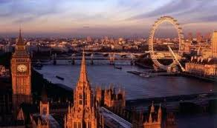

**[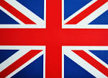](http://www.google.gr/imgres?imgurl=http://www.visitbalitoday.com/wp-content/uploads/2012/12/colors-of-england.jpg&imgrefurl=http://www.visitbalitoday.com/best-destination-in-the-worldeuropean-england-part-1.html&usg=__HxmvBySowIBmahG_CgaDrax6T9w=&h=1380&w=1920&hl=el&start=11&zoom=1&tbnid=f54PJfg_ZNTtUM:&tbnh=108&tbnw=150&ei=Y1QYU-ubLqa34wTq7oH4CQ&sa=X&ved=0CDkQrQMwCg)**

England

Architecture and gardens

English architecture begins with the [architecture of the Anglo-Saxons](http://en.wikipedia.org/wiki/Architecture_of_the_Anglo-Saxons). Other buildings such as [cathedrals](http://en.wikipedia.org/wiki/Cathedrals) and [parish](http://en.wikipedia.org/wiki/Parish) [churches](http://en.wikipedia.org/wiki/Christian_Church) are associated with a sense of traditional Englishness, as is often the palatial '[stately home](http://en.wikipedia.org/wiki/Stately_home)'. Many people are interested in the [English country house](http://en.wikipedia.org/wiki/English_country_house) and the rural lifestyle, evidenced by the number of visitors to properties managed by [English Heritage](http://en.wikipedia.org/wiki/English_Heritage) and the [National Trust](http://en.wikipedia.org/wiki/National_Trust_for_Places_of_Historic_Interest_or_Natural_Beauty).

Landscape gardening as developed by [Capability Brown](http://en.wikipedia.org/wiki/Capability_Brown) set an international trend for the [English garden](http://en.wikipedia.org/wiki/English_garden). Gardening, and visiting gardens, are regarded as typically English pursuit

[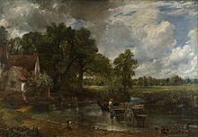](http://en.wikipedia.org/wiki/File:John_Constable_The_Hay_Wain.jpg) [English art](http://en.wikipedia.org/wiki/English_art)

The Hay Wain by [John Constable](http://en.wikipedia.org/wiki/John_Constable) is an archetypal English painting.

[magnify-clip](http://en.wikipedia.org/wiki/File:John_Constable_The_Hay_Wain.jpg)

[English art](http://en.wikipedia.org/wiki/English_art) was dominated by imported artists throughout much of the [Renaissance](http://en.wikipedia.org/wiki/Renaissance), but in the 18th century a native tradition became much admired. It is often considered to be typified by [landscape painting](http://en.wikipedia.org/wiki/Landscape_art), such as the work of [J.M.W. Turner](http://en.wikipedia.org/wiki/J.M.W._Turner) and [John Constable](http://en.wikipedia.org/wiki/John_Constable). Portraitists like [Thomas Gainsborough](http://en.wikipedia.org/wiki/Thomas_Gainsborough), [Joshua Reynolds](http://en.wikipedia.org/wiki/Joshua_Reynolds) and [William Hogarth](http://en.wikipedia.org/wiki/William_Hogarth) are also significant. Hogarth also developed a distinctive style of satirical painting.

**Cuisine**

[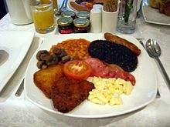](http://en.wikipedia.org/wiki/File:Full_English_Breakfast.JPG)Since the [early modern](http://en.wikipedia.org/wiki/Early_modern) era, the food of England has historically been characterised by its simplicity of approach, honesty of flavour, and a reliance on the high quality of natural produce. This has resulted in a traditional cuisine which tended to veer from strong flavours, such as [garlic](http://en.wikipedia.org/wiki/Garlic), and an avoidance of complex [sauces](http://en.wikipedia.org/wiki/Sauces) which were commonly associated with [Catholic](http://en.wikipedia.org/wiki/Catholic) [Continental](http://en.wikipedia.org/wiki/Continental_Europe) political affiliations. Traditional meals have ancient origins, such as [bread](http://en.wikipedia.org/wiki/Bread) and [cheese](http://en.wikipedia.org/wiki/Cheese), roasted and stewed meats, [meat](http://en.wikipedia.org/wiki/Meat_pie) and [game](http://en.wikipedia.org/wiki/Game_pie) pies, and freshwater and saltwater fish. The 14th-century English cookbook, the [Forme of Cury](http://en.wikipedia.org/wiki/Forme_of_Cury), contains recipes for these, and dates from the royal court of [Richard II](http://en.wikipedia.org/wiki/Richard_II_of_England).

A full English breakfast consists of scrambled eggs, [sausage](http://en.wikipedia.org/wiki/Sausage), [black pudding](http://en.wikipedia.org/wiki/Black_pudding), bacon, mushrooms, baked beans, [hash browns](http://en.wikipedia.org/wiki/Hash_browns), and half a tomato.

Modern English cuisine is difficult to differentiate from [British cuisine](http://en.wikipedia.org/wiki/British_cuisine) as a whole. However, there are some forms of cuisine considered distinctively English. The [Full English Breakfast](http://en.wikipedia.org/wiki/Full_breakfast) is a variant of the traditional British fried breakfast. The normal ingredients of a traditional full English breakfast are [bacon](http://en.wikipedia.org/wiki/Bacon), [eggs](http://en.wikipedia.org/wiki/Egg_(food)), fried or grilled [tomatoes](http://en.wikipedia.org/wiki/Tomato), fried [mushrooms](http://en.wikipedia.org/wiki/Mushroom), [fried bread](http://en.wikipedia.org/wiki/Fried_bread) or [toast](http://en.wikipedia.org/wiki/Toast), and [sausage](http://en.wikipedia.org/wiki/Sausage), usually served with a cup of [coffee](http://en.wikipedia.org/wiki/Coffee) or [tea](http://en.wikipedia.org/wiki/Tea). [Black pudding](http://en.wikipedia.org/wiki/Black_pudding) is added in some regions as well as fried leftover mashed potatoes called [potato cakes](http://en.wikipedia.org/wiki/Potato_cake) or hash browns.

[Tea](http://en.wikipedia.org/wiki/Tea) and [beer](http://en.wikipedia.org/wiki/English_beer) are typical and rather iconic drinks in England, particularly the former. Traditionally, [High Tea](http://en.wikipedia.org/wiki/High_Tea) would be had as a separate meal. [Cider](http://en.wikipedia.org/wiki/Cider) is produced in the [West Country](http://en.wikipedia.org/wiki/West_Country) and, more recently, [East Anglia](http://en.wikipedia.org/wiki/East_Anglia) and the south of England has seen the reintroduction of vineyards producing white [wine](http://en.wikipedia.org/wiki/Wine) on a small scale.

[Roast beef](http://en.wikipedia.org/wiki/Roast_beef) is a food traditionally associated with the English; the link was made famous by [Henry Fielding](http://en.wikipedia.org/wiki/Henry_Fielding)'s patriotic [ballad](http://en.wikipedia.org/wiki/Ballad) "[The Roast Beef of Old England](http://en.wikipedia.org/wiki/The_Roast_Beef_of_Old_England)", and [William Hogarth](http://en.wikipedia.org/wiki/William_Hogarth)'s [painting of the same name](http://en.wikipedia.org/wiki/The_Gate_of_Calais). Indeed, since the 1700s the phrase "les rosbifs" has been a popular French nickname for the English.

[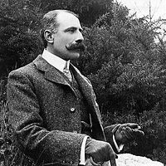](http://en.wikipedia.org/wiki/File:Edward_Elgar.jpg)

[magnify-clip](http://en.wikipedia.org/wiki/File:Edward_Elgar.jpg)

**Music**

[Edward Elgar](http://en.wikipedia.org/wiki/Edward_Elgar) is one of England's most celebrated classical composers.

England has a long and rich musical history. The United Kingdom has, like most European countries, undergone a roots revival in the last half of the 20th century. English music has been an instrumental and leading part of this phenomenon, which peaked at the end of the 1960s and into the 1970s.

**Finally, a new trend emerged from** [**Liverpool**](http://en.wikipedia.org/wiki/Liverpool) **in 1962.** [The Beatles](http://en.wikipedia.org/wiki/The_Beatles) became the most popular musicians of their time, and in the composing duo of [**John Lennon**](http://en.wikipedia.org/wiki/John_Lennon) **and** [**Paul McCartney**](http://en.wikipedia.org/wiki/Paul_McCartney)**,** popularized the concept of the self-contained music act. Before the Beatles, very few popular singers composed the tunes they performed. The "Fab Four" opened the doors for other English acts such as the [**Rolling Stones**](http://en.wikipedia.org/wiki/Rolling_Stones)**,** the idiosyncratic art rock legend [Kate Bush](http://en.wikipedia.org/wiki/Kate_Bush), [Cream](http://en.wikipedia.org/wiki/Cream_(band)), [The Hollies](http://en.wikipedia.org/wiki/The_Hollies), [The Kinks](http://en.wikipedia.org/wiki/The_Kinks), [The Who](http://en.wikipedia.org/wiki/The_Who), [Queen](http://en.wikipedia.org/wiki/Queen_(band)), [Led Zeppelin](http://en.wikipedia.org/wiki/Led_Zeppelin), [Black Sabbath](http://en.wikipedia.org/wiki/Black_Sabbath), [Genesis](http://en.wikipedia.org/wiki/Genesis_(band)), [Iron Maiden](http://en.wikipedia.org/wiki/Iron_Maiden), [The Police](http://en.wikipedia.org/wiki/The_Police) and [Pink Floyd](http://en.wikipedia.org/wiki/Pink_Floyd) to the globe.

Some of England's leading contemporary artists include [Eric Clapton](http://en.wikipedia.org/wiki/Eric_Clapton), [Elton John](http://en.wikipedia.org/wiki/Elton_John), [George Michael](http://en.wikipedia.org/wiki/George_Michael), [The Spice Girls](http://en.wikipedia.org/wiki/The_Spice_Girls), [Oasis](http://en.wikipedia.org/wiki/Oasis_(band)), [Blur](http://en.wikipedia.org/wiki/Blur_(band)), [Radiohead](http://en.wikipedia.org/wiki/Radiohead), [David Bowie](http://en.wikipedia.org/wiki/David_Bowie), [Depeche Mode](http://en.wikipedia.org/wiki/Depeche_Mode), [Def Leppard](http://en.wikipedia.org/wiki/Def_Leppard), [Take That](http://en.wikipedia.org/wiki/Take_That), [Robbie Williams](http://en.wikipedia.org/wiki/Robbie_Williams), [Coldplay](http://en.wikipedia.org/wiki/Coldplay), [Muse](http://en.wikipedia.org/wiki/Muse_(band)), [Mumford and Sons](http://en.wikipedia.org/wiki/Mumford_and_Sons), [Amy Winehouse](http://en.wikipedia.org/wiki/Amy_Winehouse),[Bring Me the Horizon](http://en.wikipedia.org/wiki/Bring_Me_the_Horizon) , [Adele](http://en.wikipedia.org/wiki/Adele) and the band [One Direction](http://en.wikipedia.org/wiki/One_Direction).

**Philosophy[**

English philosophers include [Francis Bacon](http://en.wikipedia.org/wiki/Francis_Bacon), [Sir Thomas More](http://en.wikipedia.org/wiki/Sir_Thomas_More), [John Locke](http://en.wikipedia.org/wiki/John_Locke), [Thomas Hobbes](http://en.wikipedia.org/wiki/Thomas_Hobbes), [Thomas Paine](http://en.wikipedia.org/wiki/Thomas_Paine), [Jeremy Bentham](http://en.wikipedia.org/wiki/Jeremy_Bentham), [John Stuart Mill](http://en.wikipedia.org/wiki/John_Stuart_Mill) and [Bertrand Russell](http://en.wikipedia.org/wiki/Bertrand_Russell).

**Religion[**

[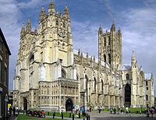](http://en.wikipedia.org/wiki/File:Canterbury_Cathedral_-_Portal_Nave_Cross-spire.jpeg)

[magnify-clip](http://en.wikipedia.org/wiki/File:Canterbury_Cathedral_-_Portal_Nave_Cross-spire.jpeg)

[Canterbury Cathedral](http://en.wikipedia.org/wiki/Canterbury_Cathedral) is the seat of the [Church of England](http://en.wikipedia.org/wiki/Church_of_England). It was the property of the [Roman Catholic Church](http://en.wikipedia.org/wiki/Roman_Catholic_Church) before the [English Reformation](http://en.wikipedia.org/wiki/English_Reformation).

**Language**

[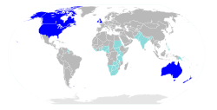](http://en.wikipedia.org/wiki/File:Anglospeak.svg)

**[magnify-clip](http://en.wikipedia.org/wiki/File:Anglospeak.svg)**

**Countries where** [**English**](http://en.wikipedia.org/wiki/English_language) **has official status or is widely spoken.**

[English people](http://en.wikipedia.org/wiki/English_people) traditionally speak the [English language](http://en.wikipedia.org/wiki/English_language), a member of the [West Germanic](http://en.wikipedia.org/wiki/West_Germanic_languages) [language family](http://en.wikipedia.org/wiki/Language_family). The modern English language evolved from [Old English](http://en.wikipedia.org/wiki/Old_English_language), with lexical influence from Norman-French, Latin, and Old Norse. There were once many different dialects in England - which were recorded in projects such as the [English Dialect Dictionary](http://en.wikipedia.org/wiki/English_Dialect_Dictionary) and the [Survey of English Dialects](http://en.wikipedia.org/wiki/Survey_of_English_Dialects) - but many of these have passed out of usage as [Standard English](http://en.wikipedia.org/wiki/Standard_English) has spread through education, the media and socio-economic press.. Because of the 19th century geopolitical dominance of the [British Empire](http://en.wikipedia.org/wiki/British_Empire) and the post-[World War II](http://en.wikipedia.org/wiki/World_War_II) hegemony of the [United States](http://en.wikipedia.org/wiki/United_States), [**English**](http://en.wikipedia.org/wiki/English_language) **has become the** [**international language**](http://en.wikipedia.org/wiki/International_auxiliary_language) **of** [**business**](http://en.wikipedia.org/wiki/Business)**,** [**science**](http://en.wikipedia.org/wiki/Science)**,** [**communications**](http://en.wikipedia.org/wiki/Communication)**,** [**aviation**](http://en.wikipedia.org/wiki/Aviation)**, and** [**diplomacy**](http://en.wikipedia.org/wiki/Diplomacy)**.**

**Science**

The English have played a significant role in the development of [science](http://en.wikipedia.org/wiki/Science) and [engineering](http://en.wikipedia.org/wiki/Engineering). Prominent individuals have included [Roger Bacon](http://en.wikipedia.org/wiki/Roger_Bacon), [Francis Bacon](http://en.wikipedia.org/wiki/Francis_Bacon), [William Harvey](http://en.wikipedia.org/wiki/William_Harvey), [Robert Hooke](http://en.wikipedia.org/wiki/Robert_Hooke), [Isaac Newton](http://en.wikipedia.org/wiki/Isaac_Newton), [Henry Cavendish](http://en.wikipedia.org/wiki/Henry_Cavendish), [Isambard Kingdom Brunel](http://en.wikipedia.org/wiki/Isambard_Kingdom_Brunel), [Francis Crick](http://en.wikipedia.org/wiki/Francis_Crick), [Abraham Darby](http://en.wikipedia.org/wiki/Abraham_Darby_I), [Michael Faraday](http://en.wikipedia.org/wiki/Michael_Faraday), [Charles Darwin](http://en.wikipedia.org/wiki/Charles_Darwin), [James Chadwick](http://en.wikipedia.org/wiki/James_Chadwick), [Joseph Swan](http://en.wikipedia.org/wiki/Joseph_Swan), [Barnes Wallis](http://en.wikipedia.org/wiki/Barnes_Wallis), [Alan Turing](http://en.wikipedia.org/wiki/Alan_Turing), [Frank Whittle](http://en.wikipedia.org/wiki/Frank_Whittle), [Sir Tim Berners-Lee](http://en.wikipedia.org/wiki/Sir_Tim_Berners-Lee) and [Stephen Hawking](http://en.wikipedia.org/wiki/Stephen_Hawking). Furthermore, it is home to the [Royal Institution](http://en.wikipedia.org/wiki/Royal_Institution), the [Royal Society](http://en.wikipedia.org/wiki/Royal_Society), the [Greenwich Observatory](http://en.wikipedia.org/wiki/Greenwich_Observatory) and its associated [meridian](http://en.wikipedia.org/wiki/Greenwich_Mean_Time).

Turkey

[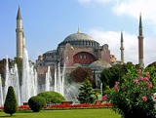](http://en.wikipedia.org/wiki/File:Turkey-3019_-_Hagia_Sophia_(2216460729).jpg)

# Geography

**Turkey is at the northeast end of the Mediterranean Sea in southeast Europe and southwest Asia. The Black Sea is to the north and the Aegean Sea is to the west. Its neighbours are Greece and Bulgaria to the west, Russia, Ukraine, and Romania to the north and northwest (through the Black Sea), Georgia, Armenia, Azerbaijan, and Iran to the east, and Syria and Iraq to the south. The Dardanelles, the Sea of Marmara, and the Bosporus divide the country. Turkey in Europe comprises an area about equal to the state of Massachusetts. Turkey in Asia is about the size of Texas. Its centre is a treeless plateau rimmed by mountains.**

[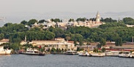](http://en.wikipedia.org/wiki/File:Topkap%C4%B1_-_01.jpg)**Starting around 1200 BC, the coast of** [**Anatolia**](http://en.wikipedia.org/wiki/Anatolia) **was heavily settled by** [**Aeolian**](http://en.wikipedia.org/wiki/Aeolians) **and** [**Ionian**](http://en.wikipedia.org/wiki/Ionians)[**Greeks**](http://en.wikipedia.org/wiki/Ancient_Greece)**. Numerous important cities were founded by these colonists, such as** [**Miletus**](http://en.wikipedia.org/wiki/Miletus)**,** [**Ephesus**](http://en.wikipedia.org/wiki/Ephesus)**,** [**Smyrna**](http://en.wikipedia.org/wiki/Smyrna) **and** [**Byzantium**](http://en.wikipedia.org/wiki/Byzantium)**, the latter founded by** [**Greek**](http://en.wikipedia.org/wiki/Greeks) **colonists from** [**Megara**](http://en.wikipedia.org/wiki/Megara) **in 657 BC. The first state that was called** [**Armenia**](http://en.wikipedia.org/wiki/Armenia) **by neighbouring peoples was the state of the** [**Armenian**](http://en.wikipedia.org/wiki/Armenians)[**Orontid dynasty**](http://en.wikipedia.org/wiki/Orontid_dynasty)**, which included parts of eastern Turkey beginning in the 6th century BC. In Northwest Turkey, the most significant tribal group in Thrace was the** [**Odyrisians**](http://en.wikipedia.org/wiki/Odrysian_kingdom)**, founded by** [**Teres I**](http://en.wikipedia.org/wiki/Teres_I)**.**[**[33]**](http://en.wikipedia.org/wiki/Turkey#cite_note-LewisBoardman1994-33#cite_note-LewisBoardman1994-33)

**[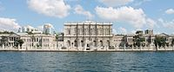](http://en.wikipedia.org/wiki/File:Dolmabah%C3%A7e_Palace_(cropped).JPG)Anatolia was conquered by the Persian** [**Achaemenid Empire**](http://en.wikipedia.org/wiki/Achaemenid_Empire) **during the 6th and 5th centuries BC and later fell to** [**Alexander the Great**](http://en.wikipedia.org/wiki/Alexander_the_Great) **in 334 BC,**[**]**](http://en.wikipedia.org/wiki/Turkey#cite_note-PersiansInAsiaMinor-34#cite_note-PersiansInAsiaMinor-34) **which led to increasing cultural homogeneity and** [**Hellenization**](http://en.wikipedia.org/wiki/Hellenization) **in the area. Following Alexander's death in 323 BC, Anatolia was subsequently divided into a number of small** [**Hellenistic kingdoms**](http://en.wikipedia.org/wiki/Hellenistic_civilization)**, all of which became part of the** [**Roman Republic**](http://en.wikipedia.org/wiki/Roman_Republic) **by the mid-1st century BC. The process of** [**Hellenization**](http://en.wikipedia.org/wiki/Hellenization) **that began with Alexander's conquest accelerated under Roman rule, so that by the early centuries AD the local** [**Anatolian languages**](http://en.wikipedia.org/wiki/Anatolian_languages) **and cultures has become extinct, replaced by Greek.**

[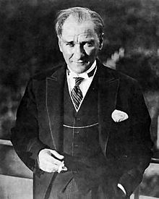](http://en.wikipedia.org/wiki/File:MustafaKemalAtaturk.jpg)[Mustafa Kemal Atatürk](http://en.wikipedia.org/wiki/Mustafa_Kemal_Atat%C3%BCrk), founder and first President

**By 18 September 1922, the occupying armies were expelled, and the** [**Ankara-based Turkish regime**](http://en.wikipedia.org/wiki/Turkish_Provisional_Government)**, which declared itself the legitimate government of the country in April 1920, started to formalize the legal transition from the old Ottoman into the new Republican political system. On 1 November, the** [**newly founded parliament**](http://en.wikipedia.org/wiki/Grand_National_Assembly_of_Turkey) **formally abolished the** [**Sultanate**](http://en.wikipedia.org/wiki/Sultan)**, thus ending 623 years of Ottoman rule. The** [**Treaty of Lausanne**](http://en.wikipedia.org/wiki/Treaty_of_Lausanne) **of 24 July 1923 led to the international recognition of the sovereignty of the newly formed "Republic of Turkey" as the continuing state of the Ottoman Empire, and the republic was officially proclaimed on 29 October 1923 in** [**Ankara**](http://en.wikipedia.org/wiki/Ankara)**, the country's new capital The Lausanne treaty stipulated a** [**population exchange between Greece and Turkey**](http://en.wikipedia.org/wiki/Population_exchange_between_Greece_and_Turkey)**, whereby 1.1 million Greeks left Turkey for Greece in exchange for 380,000 Muslims transferred from Greece to Turkey. Mustafa Kemal became the republic's first** [**President**](http://en.wikipedia.org/wiki/President_of_Turkey) **and subsequently introduced** [**many radical reforms**](http://en.wikipedia.org/wiki/Atat%C3%BCrk%27s_Reforms) **with the aim of transforming old Ottoman-Turkish state into a new secular republic. With the** [**Surname Law**](http://en.wikipedia.org/wiki/Surname_Law_(Turkey)) **of 1934, the** [**Turkish Parliament**](http://en.wikipedia.org/wiki/Turkish_Parliament) **bestowed upon Mustafa Kemal the honorific surname "Atatürk" (Father of the Turks.)**[**]**](http://en.wikipedia.org/wiki/Turkey#cite_note-Atat.C3.BCrk-8#cite_note-Atat.C3.BCrk-8)**Turkey** [**remained neutral**](http://en.wikipedia.org/wiki/Second_Cairo_Conference) **during most of** [**World War II**](http://en.wikipedia.org/wiki/World_War_II)**, but entered the closing stages of the war on the side of the** [**Allies**](http://en.wikipedia.org/wiki/Allies_of_World_War_II) **on 23 February 1945. On 26 June 1945, Turkey became a** [**charter member**](http://en.wikipedia.org/wiki/United_Nations_Charter) **of the United Nations. Difficulties faced by Greece after the war in quelling a** [**communist rebellion**](http://en.wikipedia.org/wiki/Greek_Civil_War)**, along with demands by the** [**Soviet Union**](http://en.wikipedia.org/wiki/Soviet_Union) **for military bases in the** [**Turkish Straits**](http://en.wikipedia.org/wiki/Turkish_Straits)**, prompted the** [**United States**](http://en.wikipedia.org/wiki/United_States) **to** declare the [**Truman Doctrine**](http://en.wikipedia.org/wiki/Truman_Doctrine) **i**n 1947. **The doctrine enunciated American intentions to guarantee the security of Turkey and Greece, and resulted in large-scale** [**U.S. military and economic support**](http://en.wikipedia.org/wiki/Turkey-United_States_relations)**. Both countries were included in the** [**Marshall Plan**](http://en.wikipedia.org/wiki/Marshall_Plan) **and** [**OEEC**](http://en.wikipedia.org/wiki/Organisation_for_European_Economic_Co-operation) **for rebuilding European economies in 1948, and subsequently became founding members of** the [OECD](http://en.wikipedia.org/wiki/Organisation_for_Economic_Co-operation_and_Development) in 1961.**After participating with the United Nations forces in the** [**Korean War**](http://en.wikipedia.org/wiki/Korean_War)**, Turkey joined** [**NATO**](http://en.wikipedia.org/wiki/NATO) **in 1952, becoming a bulwark against Soviet expansion into the** [**Mediterranean**](http://en.wikipedia.org/wiki/Mediterranean_Basin)**.**

**Following a decade of** [**Cypriot intercommunal violence**](http://en.wikipedia.org/wiki/Cypriot_intercommunal_violence) **and the** [**coup in Cyprus on 15 July 1974**](http://en.wikipedia.org/wiki/1974_Cypriot_coup_d%27%C3%A9tat) **staged by the** [**EOKA B**](http://en.wikipedia.org/wiki/EOKA_B) **paramilitary organization, which overthrew President** [**Makarios**](http://en.wikipedia.org/wiki/Makarios_III) **and installed the pro-**[**Enosis**](http://en.wikipedia.org/wiki/Enosis) **(union with Greece)** [**Nikos Sampson**](http://en.wikipedia.org/wiki/Nikos_Sampson) **as dictator,** [**Turkey invaded Cyprus**](http://en.wikipedia.org/wiki/Turkish_invasion_of_Cyprus) **on 20 July 1974. Nine years later the** [**Turkish Republic of Northern Cyprus**](http://en.wikipedia.org/wiki/Turkish_Republic_of_Northern_Cyprus)**, which is recognized only by Turkey, was established.**

# Finland

**Finland (Republic of Finland, is a** [**Nordic country**](http://en.wikipedia.org/wiki/Nordic_countries) **situated in the** [**Fennoscandian**](http://en.wikipedia.org/wiki/Fennoscandia) **region of Northern Europe. It is bordered by** [**Sweden**](http://en.wikipedia.org/wiki/Sweden) **to the west,** [**Norway**](http://en.wikipedia.org/wiki/Norway) **to the north,** [**Russia**](http://en.wikipedia.org/wiki/Russia) **to the east, and** [**Estonia**](http://en.wikipedia.org/wiki/Estonia) **to the south across the** [**Gulf of Finland**](http://en.wikipedia.org/wiki/Gulf_of_Finland)**.**

As of 2012, Finland's population was around 5.4 million, with the majority concentrated in its southern regions In terms of area, it is the [eighth largest country in Europe](http://en.wikipedia.org/wiki/Area_and_population_of_European_countries) **and the most** [**sparsely populated**](http://en.wikipedia.org/wiki/List_of_sovereign_states_and_dependent_territories_by_population_density) **country in the** [**European Union**](http://en.wikipedia.org/wiki/European_Union)**.** Finland is a [parliamentary](http://en.wikipedia.org/wiki/Parliamentary_system) republic with a central government based in the capital of [Helsinki](http://en.wikipedia.org/wiki/Helsinki), local governments in 336 [municipalities](http://en.wikipedia.org/wiki/Municipalities_of_Finland) and an [autonomous region](http://en.wikipedia.org/wiki/Autonomous_area), the [Åland Islands](http://en.wikipedia.org/wiki/%C3%85land_Islands). About one million residents live in the [Greater Helsinki](http://en.wikipedia.org/wiki/Greater_Helsinki) area (consisting of Helsinki, [Espoo](http://en.wikipedia.org/wiki/Espoo), [Vantaa](http://en.wikipedia.org/wiki/Vantaa) and [Kauniainen](http://en.wikipedia.org/wiki/Kauniainen)), which also produces a third of the country's [GDP](http://en.wikipedia.org/wiki/Gross_domestic_product). Other large cities include [Tampere](http://en.wikipedia.org/wiki/Tampere), [Turku](http://en.wikipedia.org/wiki/Turku), [Oulu](http://en.wikipedia.org/wiki/Oulu), [Jyväskylä](http://en.wikipedia.org/wiki/Jyv%C3%A4skyl%C3%A4), [Lahti](http://en.wikipedia.org/wiki/Lahti), and [Kuopio](http://en.wikipedia.org/wiki/Kuopio).

[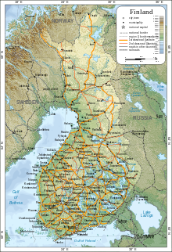](http://en.wikipedia.org/wiki/File:Map_of_Finland-en.svg)

**Finland is a country of thousands of lakes and islands—about 188,000 lakes (larger than 500 m2 or 0.12 acre) and 179,000 islands. Its largest lake,** [**Saimaa**](http://en.wikipedia.org/wiki/Saimaa)**, is the fourth largest in Europe. The area with most lakes is called** [**Finnish Lakeland**](http://en.wikipedia.org/wiki/Finnish_Lakeland)**. The greatest concentration of islands is found in the southwest in the** [**Archipelago Sea**](http://en.wikipedia.org/wiki/Archipelago_Sea) **between continental Finland and the main island of Åland.**

**Much of the geography of Finland is explained by the Ice Age. The glaciers were thicker and lasted longer in** [**Fennoscandia**](http://en.wikipedia.org/wiki/Fennoscandia) **compared with the rest of Europe. Their eroding effects have left the Finnish landscape mostly flat with few hills and fewer mountains. Its highest point, the** [**Halti**](http://en.wikipedia.org/wiki/Halti) **at 1,324 metres (4,344 ft), is found in the extreme north of Lapland at the border between Finland and** [**Norway**](http://en.wikipedia.org/wiki/Norway)**. The highest mountain whose peak is entirely in Finland is** [**Ridnitsohkka**](http://en.wikipedia.org/wiki/Ridnitsohkka) **at 1,316 m (4,318 ft), directly adjacent to Halti.**

**[magnify-clip](http://en.wikipedia.org/wiki/File:Cygnus_cygnus_from_zh.JPG)**

**[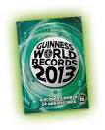](http://www.google.gr/imgres?imgurl=http://4.bp.blogspot.com/-lRQWCQbTzA8/UPhTwEERpTI/AAAAAAAAADA/VM4ddqJ8XaM/s1600/GWR+cover.png&imgrefurl=http://theaditiblog.blogspot.com/2013/01/some-interesting-but-mostly-stupid.html&usg=__1i3IXgASYSFHYXpksJ3qy8y5WbE=&h=561&w=451&hl=el&start=6&zoom=1&tbnid=eX9IXzRyKtAugM:&tbnh=133&tbnw=107&ei=1iUoU_elPKzo7AbkooHgBA&sa=X&ved=0CC4QrQMwBQ)Guinness World Records**, known until 2000 as **The Guinness Book of Records** and in previous U.S. editions as **The Guinness Book of World Records**, is a [reference book](http://en.wikipedia.org/wiki/Reference_book) published annually, containing a collection of [world records](http://en.wikipedia.org/wiki/World_record), both human achievements and the extremes of the natural world. The book itself holds a world record, as the best-selling copyrighted book of all timeIt is also one of the most frequently stolen books from public libraries in the United States.

## [http://upload.wikimedia.org/wikipedia/commons/thumb/4/46/6764_Guinness.JPG/220px-6764_Guinness.JPG](http://en.wikipedia.org/wiki/File:6764_Guinness.JPG)Museum

[magnify-clip](http://en.wikipedia.org/wiki/File:6764_Guinness.JPG)

Guinness Museum in [Hollywood](http://en.wikipedia.org/wiki/Hollywood)

In 1976, a Guinness Book of World Records museum opened in the [Empire State Building](http://en.wikipedia.org/wiki/Empire_State_Building). Speed shooter [Bob Munden](http://en.wikipedia.org/wiki/Bob_Munden) then went on tour promoting The Guinness Book of World Records by performing his record fast draws with a standard weight single-action revolver from a western movie type holster. His fastest time for a draw was .02 seconds[Among exhibits were life-size statues of the world's tallest man ([Robert Wadlow](http://en.wikipedia.org/wiki/Robert_Wadlow)) and world's largest earth worm, an X-ray photo of a sword swallower, repeated lightning strike victim [Roy Sullivan](http://en.wikipedia.org/wiki/Roy_Sullivan)'s hat complete with lightning holes and a pair of gem-studded golf shoes on sale for $6500. The museum closed in 1995

In more recent years the Guinness company has permitted the [franchising](http://en.wikipedia.org/wiki/Franchising) of small museums with displays based on the book, all currently (as of 2010) located in towns popular with tourists: [Tokyo](http://en.wikipedia.org/wiki/Tokyo), [Copenhagen](http://en.wikipedia.org/wiki/Copenhagen), [San Antonio](http://en.wikipedia.org/wiki/San_Antonio). There were once Guinness World Records museums and exhibitions at the [Trocadero](http://en.wikipedia.org/wiki/Trocadero_(London)) in London, [Bangalore](http://en.wikipedia.org/wiki/Bangalore), [San Francisco](http://en.wikipedia.org/wiki/San_Francisco), [Myrtle Beach](http://en.wikipedia.org/wiki/Myrtle_Beach,_South_Carolina), [Orlando](http://en.wikipedia.org/wiki/Orlando,_Florida), [Atlantic City](http://en.wikipedia.org/wiki/Atlantic_City,_New_Jersey), New Jersey, and [Las Vegas](http://en.wikipedia.org/wiki/Las_Vegas_Valley), [Nevada](http://en.wikipedia.org/wiki/Nevada). The Orlando museum, which closed in 2002, was branded The Guinness Records Experience; the Hollywood, [Niagara Falls](http://en.wikipedia.org/wiki/Niagara_Falls), Copenhagen, and [Gatlinburg](http://en.wikipedia.org/wiki/Gatlinburg,_Tennessee), Tennessee museums also previously featured this branding.

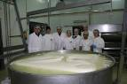**by Gouskou konstandinou**

**GUINNESS RECORDs**

**Greece**

Cheese- making unit in Irises of Chalcidice where they

make the hugest caprice cheese in the world. The

Guinness Book of World Records featured the representative

of the Guinness World Records, Jack Brock bank gave the certificate of the inscription

in the book of the world records to the owner of the dairy Ionic Stators, within the 21st International

Exhibition of Food and Drinks Destroy. “The cheese under the name of “

**caprice rock”** weighted 939 kilos”, stated Ionic Stators who looked really proud of his achievement.

# Giant Dakos Aspires for Guinness World Records

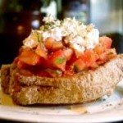**The cultural association To Rhoda in Crania, Crete, is making a giant dakos. For those who may not know, dakos is a Cretan maze, consisting of a slice of soaked dried bread or barley rusk (paximadi) topped with chopped tomatoes and crumbled feta or mizithra cheese, olives and flavored with herbs such as dried oregano.The makers of this enormous dakos aspire to see it written in the book of Guinness World Records. Its presentation will take place in the afternoon of Sunday August 25 at Agios Apostolis Park, in Crania, as part of the two-day cultural events organized by the Municipality of Crania in cooperation with the association**

**To Rhoda.Indeed, the dakos that will be presented during the event will be the biggest rusk in the**

**world and will have the shape of the island of Crete. In particular, its dimensions will be 1.80 x 8 meters.**

**During its preparation, that will last four days in total, the dakos will be separated in four big pieces**

**representing the island’s four regional units and each piece will have dimensions of 1.80 x 2 meters.**

**Then it will be baked and put back together.For the preparation of this giant dakos, whole wheat flour,**

**barley, yeast, olive oil and salt are used, while the dough alone will weigh 160 kilos.**

**while the events will be accompanied by traditional music groups from all around the Chania region.**

**Dakos is a well loved traditional dish of Crete, as it can be made easily and fast, while it constitutes**

**a complete and nutritious meal, especially preferred by the clients of restaurants and taverns**

**Switzerland breaks world record free diver for underwater breath holding  
Colat, 38, performed the feat in a water tank in St Gallen, Switzerland .  
Peter Colat, a Swiss freediver, has held his breath in the water for 19 minutes and 21 seconds , Colat, , said the first 12 minutes was no problem. He said: "I felt the first need to breathe very late, but because of this it was even stronger." He said : " I felt the first need to breathe very slowly , but because it was even stronger. "  
Under the Guinness rules he was allowed to inhale pure oxygen 10 minutes prior to his attempt.** [magnify-clip](http://en.wikipedia.org/wiki/File:Parnitha_Fire.jpg)

**FIRE**

**Parnitha Thrakomakedones our area**

**by lazaridi d.**

**Welcome to the National Park of Parnitha!**

**Mt Parnitha is located in Sterea Ellas (Central Greece) and is the highest mountain in the vicinity of Athens. It extends in a large area, presenting variable topography with several summits, gorges, streams and plateaus.In 1961 the entire mountain (~25,000 hectares) was declared a National Park.The arrangement of the rocks favours the existence of 46 springs, which flow continuously and form several streams and small ponds.. The Kithara spring is well known for supplying the Hadrian Aqueduct, which was completed in 140 A.D. and consisted primarily of an underground tunnel, 25 km. long, which was constructed manually through solid rock by hundreds of slaves using simple tools such as chisels and hammers. The aqueduct was designed not only to transfer water towards the city but also to collect it through a number of smaller catchment works along the way. The Hadrian Aqueduct began at the foot of Mount Parnitha in the area of Tatoi and transported water by gravity to a stone reservoir on the hill of Lycabettus in the city of Athens. The most beautiful precipices are in Keramidi (27 m depth), Tamilthi (35 m depth), Gkoura (20 m depth), Dekeleia (20 m depth) and Ntabelis'(8 m depth, 200 m2 cave).**

[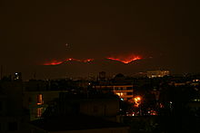](http://en.wikipedia.org/wiki/File:Parnitha_Fire.jpg)

View of the Parnitha National Park fire from north Athens

**The first major fire of the summer of 2007 was started on 28 June 2007.**[**[1]**](http://en.wikipedia.org/wiki/2007_Greek_forest_fires#cite_note-first-1#cite_note-first-1) **It is perceived to have been started by either an exploding** [**electrical pylon**](http://en.wikipedia.org/wiki/Electricity_pylon) **or by arsonists.**[**[1]**](http://en.wikipedia.org/wiki/2007_Greek_forest_fires#cite_note-first-1#cite_note-first-1) **Significant parts of the** [**Parnitha**](http://en.wikipedia.org/wiki/Parnitha) **National Park were destroyed,**[**[1]**](http://en.wikipedia.org/wiki/2007_Greek_forest_fires#cite_note-first-1#cite_note-first-1) **and in total, the fire burnt 15,723 acres (63.6 km2)**[**[11]**](http://en.wikipedia.org/wiki/2007_Greek_forest_fires#cite_note-ypexode-11#cite_note-ypexode-11) **of the core of the national forest in a matter of days. Overall the mountain of Parnitha suffered a burnt area of 38,000 acres (153.8 km2),**[**[11]**](http://en.wikipedia.org/wiki/2007_Greek_forest_fires#cite_note-ypexode-11#cite_note-ypexode-11) **making it one of the worst recorded wildfires in** [**Attica**](http://en.wikipedia.org/wiki/Attica) **since the** [**Penteli**](http://en.wikipedia.org/wiki/Penteli) **fire of July 1995.**[**[12]**](http://en.wikipedia.org/wiki/2007_Greek_forest_fires#cite_note-parnitha-12#cite_note-parnitha-12)

by danai lazaridi

 Protect the environment

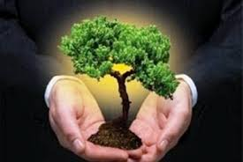The planet is very important for all of us and therefore need to protect. See below 30 simple ways we can all help!  
  
1. Plant a tree. Absorbs 4.5 pounds of carbon dioxide every year. Trees absorb carbon dioxide from the air and use it as an energy source, releasing oxygen, so essential for us.  
  
2. Less trash. In Greece produced 3,000,000 tons of trash without counting industrial and hospital waste. Only 8 % is recycled in our country.  
  
3. Smart driving means to gradually increase the speed to combine your jobs to make one trip.  
  
4. Choose organic. Prefer organic vegetables and organic livestock products.  
  
5. Law - Commerce. When you buy something, think of where it comes from and how it is produced? None? But if you did, could affect global trade.  
  
6. In fish size does not matter and the smaller the worse. The fine koutsoumoura or Maridaki is not the delicacy to sate the ecological consciousness.  
  
7. Electronic junk. Beware of electrical and electronic waste. Do not flush with the rest of the bins because they contain many dangerous substances. A battery of cadmium contaminates 600,000 liters of water.  
  
8. Recycle recycling. Choose products with packaging more environmentally friendly, such as glass, aluminum and paper.  
  
9. Change the lights. According to Greenpeace, only 10 % of the energy consumed by incandescent lamps used for lighting. The remaining 90 % is heat and lost.  
  
10. Eco Drive. Hybrid cars are absolutely clear about the city and consume almost half of the remaining gasoline.  
  
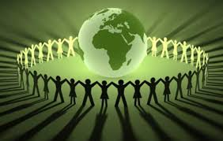11. Slow down, please. Reduce noise, if not for the health of the planet , at least yours.  
  
12. Bag or life? Manufactured in one second, used 10 minutes and dissolved in 50 years . Plastic bags are a risk to life for all marine creatures drowns them.  
  
13. Throw something on you. If you have central heating arrange to set the heater thermostat a little lower than you're used to.  
  
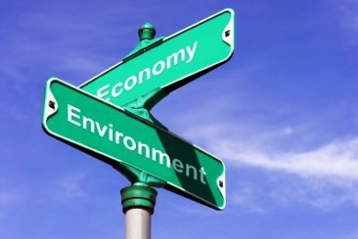14. Solar energy. The energy from the sun in a country like ours is already the first houses. The average daily energy you get from the sun in Greece is 4.6 kilowatt hours per square meter.  
  
15. No other charcoal. No more fires. The fires of last summer are not forgotten. There goes another, we arrived at absolute zero.

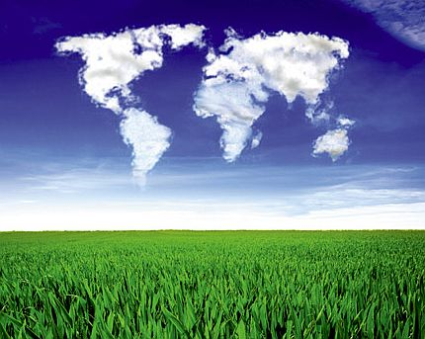16. Most green. Athens remains the capital to less green.  
  
17. Houseplants. They are best friends for those working in confined spaces. Plants absorb air pollutants and clean.  
  
18. Make friends, not markets. Many things do not need to buy. Let's be good friends. Borrow. Also share with their car journeys.  
  
19. Refuse well-traveled food. «Act globally, eat locally», is the motto .  
  
20. Learn about composting . It is the natural process in which organic waste is turned into a rich organic mixture that acts as a fertilizer.  
  
21. Not on exotic birds. Do not buy pet since been removed from their natural environment.  
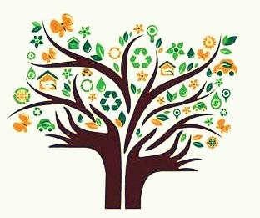22. Metro, tram, trolley buses . The car has a stake of 75-90 % in air pollution in cities.  
  
23. The temperance benefits serious nature. According to one study, 15% of European adults are addicted to consumption and 46 % of young people consuming excessive rate.  
  
24. Alternative tourism. Select train instead of 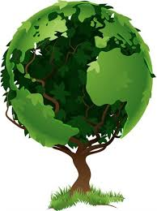the plane, at least for short distances.  
  
25. Reuse. The right is to reduce overconsumption.  
  
26. Economy in the water. Do not leave the tap open unnecessarily. Do not wash your car with a hose, but with bucket.  
  
27. Classic clothes. Badges with classic lines that you can wear them and enjoy them very long.  
  
28. Reuse linens, towels. In the hotel ask to change your sheets and towels every other day.  
  
29. Caution on your computer. If you operate a daily five hours, emits 250 pounds of greenhouse gases in a year. A laptop makes economy 90 %.  
  
30. Organize. Join an environmental organization to eat before we eat.

BY DANAE LAZARIDI

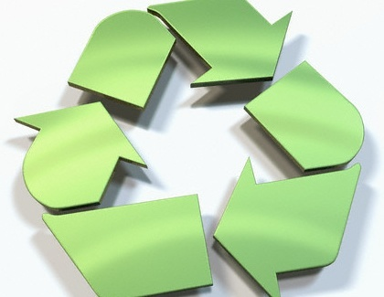

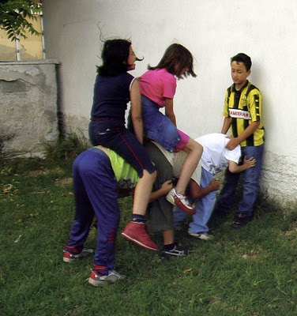**The donkey away**

**The donkey away childish games played by boys with different variations throughout Greece, especially in older years.   
  
The game is played by two teams. The members of a formed a series bowed, with one to have your back to the other. The children of the other group took time and jumped over her children until the first climb on the back all the "donkeys". If you are coping without their children throw the other team, you win.**

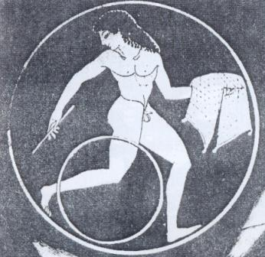**Wheel   
  
The wheels are usually copper and there are larger and smaller. The diameter varies between 80 and 130 centimeters. The wheel is not only a game. And was used in gyms where young exercised. Even Hippocrates, the famous physician, in his book "On Diet," introduces him to those who want to keep fit.**

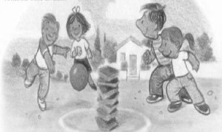**Mosque   
  
Slightly more complex, the mosque requires at least ten players divided into two teams and a tile**-**seven pieces or absence of ceramide, simple flat stones staged one over the other. One group marks the ball and throws the pile. Then try rebuilding of the stones in a row, as his rivals are trying to accomplish with the balls to make the game. If one group managed to reinstall the stack, shout 'mosque' and winning the 'batch'.**

**MUSIC**

**Music: The Ancient elements of** [**Greek music**](http://www.in2greece.com/english/music/music.htm) **can be found in the music of the Greeks of the Black sea (Pontos), in the ancient sound of the goat skin bagpipes (Tsampounes) on many Greek islands , in the sounds of the flute of the Greek shepherds in northern Greece and in the sounds of the Cretan Lyra in Crete. All of these Byzantine and ancient elements come together with the Smyrneika. Smyrneika is the music that the Greeks of Asia Minor brought with them and is the most typical of Greek folk music. However, as in the past so as today, the Greeks love to mix things, with the consequence that Greek music has adapted and adopted the musical elements from the West including Latin rhythms and sounds, Italian music, Rock and Blues as well as rap and hip hop music.**